GAN Specialization

Course 1: Build basic Generative Adversarial Networks

Week 1 :

1. Video 1 : Welcome
   * Emergent class of DL
   * Bildt cat image GAN’s
   * Generate picture of people that had never existed
   * Make someone look younger or older
   * Low resolution video to high resolution video
   * Supervized learning task: classify object, or X-ray images and you don’t have images => sensitize more data
   * Perform image editing
   * They are not complex
   * Art forger
   * Art inspector
   * Try to figure out which one are real and which one are fake
   * Generate realistic images
   * You like your furniture more if you build it yourself
   * Implement our own GAN
   * Get creative
   * Advanced DL topics and algorithms
   * NN, CNN, Python, DL framework
2. Video 2: GAN’s
   * Unsupervized technique
   * Intuition
   * Two models behind GAN’s: Generator / Discriminator
   * Generate realistic images
   * Use pytorch
3. Video 3: Generative models
   * Generate realistic images or music
   * How GAN’s work
   * Build your GAN that generate handwritten digits
   * 2 of the most popular GAN’s model architecture
   * Discriminative models / Generative models
   * Discriminative model: use for classification in machine learning => learn how to distinguish between classes => classifiers
   * Get Feature X => determine class Y
   * Generative learn how to make a realistic representation
   * Get Noise + Class Y => determine Features X
   * Why do we need noise? => to ensure that what generated isn’t actually the same image each time => else it will be pointless
   * We need realistic and diverse representations of this class
   * 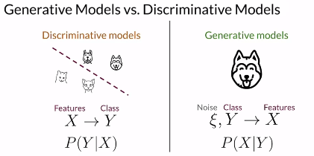
   * We could generate a dataset
   * 2 popular generative models:
   * Variational Auto-Encoders: VAE
   * Generative Adversarial Networks: GAN
   * VAE work with and encoder and a decoder => neural network
   * Fit realistic images to the encoder
   * Encoder find good way of representing images
   * The decoder reconstructs images
   * In the beginning the decoder would not be able to reconstruct images
   * We inject some noise to the model
   * GAN’s work on a different way
   * Generator / Discriminator
   * Generator => generate the images
   * Take random noise input as vector and some image
   * Output the same image => very similar to decoder => there is no encoder that determine how the noise should look like
   * Discriminator look at fake and real images => and try to figure out which one are real and which one are fake
   * They work with each other => adversarial => they learn from each other
   * They learn from each other until we don’t need the discriminator anymore
   * Generator will take any random noise and produce a realistic image
   * 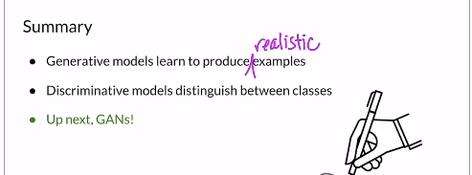
   * Generative => produce realistic examples => kind of an artist that learn how to paint realistic images
   * Discriminative model could be a sub component of generative model
   * Real / fake classes
   * The two models in a GAN compete with each other and reach a point where realistic examples are produced by the generator.
4. Video 4: Real Life GAN’s
   * Applications of GAN
   * Major Companies using them
   * Ian Goodfelew
   * Black and white images to colored photo realistic
   * High resolution realistic images
   * People that doesn’t exist look real
   * StyleGAN2
   * Producing cat
   * Generative are not perfect
   * Mimic the distribution
   * Meme cats => will contain words
   * GAN perform image translation
   * From one domain to another
   * CycleGAN: ex from horse to a zebra
   * Don’t need horses and zebra doing the same thing
   * Just one and transform it to the other
   * GauGAN
   * Draw
   * Doodles => pictures
   * Animate a portrait
   * 3D-Object
   * Generative design
   * Application in medicine
   * Adobe next generation of Photoshop
   * Google text generation
   * IBM data augmentation
   * Snapchat and tic-tac image filters
   * Disney super resolution
5. Video 5: Intuition behind GAN’s
   * Produce realistic object
   * Difficult to distinguish from existing real one
   * Learns making a generator and a discriminator complete against each other
   * The goal of generator and discriminator
   * The competition between them
   * 2 components => 2 different neural networks: Generator/Discriminator
   * Generator: learn to generate things that look real => painter
   * Discriminator: learns to distinguish between what’s real and what’s fake => art inspector
   * Generator fake images to try to make them loos as realistic as possible
   * It does this in the hopes of fooling the discriminator
   * 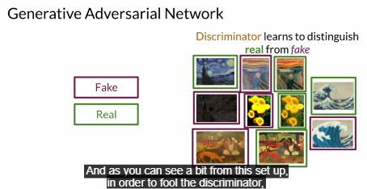
   * Generator will work harder to get the fake one look real
   * In order to catch generator, discriminator will try to learn how to not get fooled
   * All what you need: collection of real images
   * At the beginning the generator isn’t sophisticated
   * The generator isn’t allowed to see the real images => it does not know how the painting should even look
   * The discriminator looks at fake + real images and learn how to decide
   * Generator will know which way to go and how to improve by looking to the scores assigned to her work by the discriminator
   * 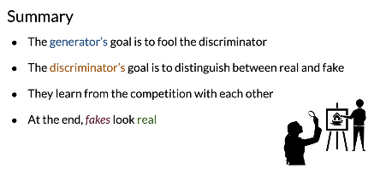
   * The generator’s goal is to create fake images to trick the discriminator.
   * The discriminator’s goal is to correctly classify the generator’s fake images as fake and the real images as real.
6. Video 6: Discriminator
   * How discriminators work
   * Review classifiers / the role of classifiers in terms of probability
   * Classifier distinguish between different classes
   * Cat / not cat
   * Use neural networks
   * Features X / labels Y associated to the classes
   * Neural network learns parameters = nodes
   * Changes as it learns
   * Map feature X to label y
   * Y-hat
   * Minimize the difference between y and y-hat
   * Cost function => how closely how much y is close to y-hat
   * Update parameters according to the gradient of cost function => on which direction you should go
   * Probability of each class
   * 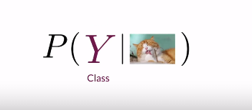
   * X => pixels
   * Probability of output class Y condition on input features X
   * Conditional probability
   * Discriminator inspect the examples => real of fake class
   * How fake this image is
   * Proba of fake or real => proba fake = 1 – proba real
   * 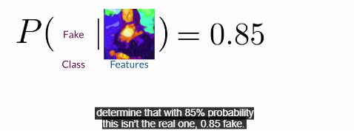
   * 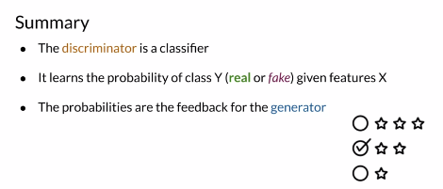
   * The discriminator finds the probability of class y (real or fake) given input features x.
7. Video 7: Generator
   * Generator is like heart
   * High performance at the end of training
   * Goal => produce examples of a certain class
   * Different examples => input noise vector
   * Include the class
   * Compute from nonlinear inputs
   * Output pixels’ image
   * Different noise vectors
   * Generator learning
   * We want y-d close to 1
   * 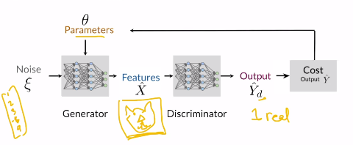
   * Good generator => save parameters theta
   * Freeze theta values
   * Samples from this generator
   * New noise vector => sample to the saved parameters
   * Model probability of features given class y
   * 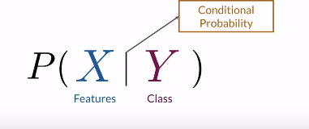
   * 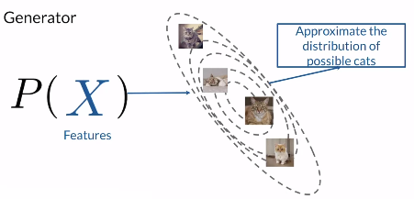
   * 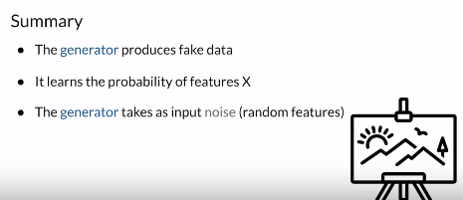
8. Video 8: BCE cost function
   * Binary cross entropy function
   * Used for training GAN’s
   * Loss equation
   * 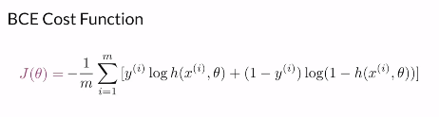
   * Average loss at the whole batch
   * M number of examples
   * H prediction
   * Y label
   * X features
   * Theta parameters of discriminator
   * One part relevant when the prediction is 0 the other is relevant when the prediction is 1
   * We add the – at the beginning to ensure that the cost is always greater or equal to 0
   * 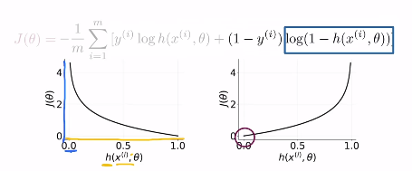
   * Prediction and the ground truth
   * 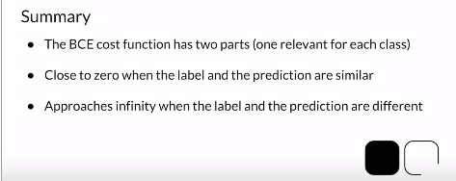
9. Video 9: putting it all together
   * How to train a GAN?
   * Generator produce fake images
   * Fakes + Real pass to discriminator
   * 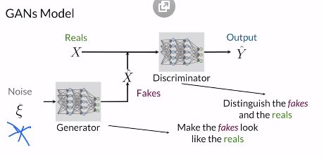
   * Discriminator made predictions y-hat which one is real and which one is fake
   * 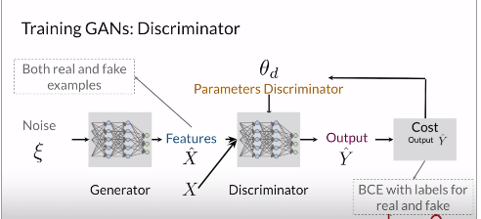
   * Update only discriminator and not the generator
   * Train generator
   * Only knows that this are fake images
   * Discriminator wants fake images to look most fake as possible
   * Generator want fake images to look most realistic as possible
   * Adversarial
   * 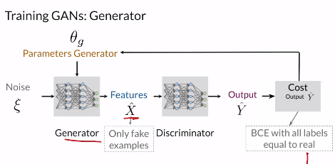
   * Only one model trains at time
   * The discriminator looks at real and fake images over time, makes guesses, and gets feedback on whether its guess was right or wrong.

Over time, it learns to discern real from fake better, but note that since the generator is also learning, the fake images get more realistic and harder to discern. This cat and mouse game enables both models to learn in tandem.

* + With feedback from the discriminator on whether a fake image looks real or fake, the generator starts producing fake images that are more and more realistic (that tries to fool the discriminator). Images that look “fake” to the discriminator are discarded in favor of those that look “real” to the discriminator; since the discriminator is improving over time as it sees more reals and fakes, the generator needs to continually learn too.
  + Both models should improve together
  + Discriminator superior to generator => all fake images are 100% fake => generator will not know how to improve => will not know which direction to go on
  + Superior generator => all images will look realistic to discriminator => all generated images are real
  + Both model should improve together
  + This is largely for discriminator
  + Discriminator has the easiest task
  + Now way to improve
  + 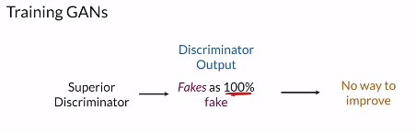
  + Need much improvise information from the discriminator output
  + 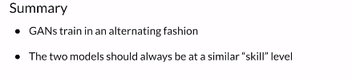
  + Both models close to each other to improve training

They need to learn from each other over time.

If one model significantly better than the other, it doesn’t help the other learn because the feedback isn’t useful. Imagine if you were a beginning artist, and you showed your work to an art expert, asking whether your painting looked like a famous piece and all they said was ‘no’. Because they have a very discerning eye, they know your image is not right, but won’t be able to tell you how close you are.

1. Video 10: Introduction to Pytorch
   * Deep learning framework developed by Facebook
   * Similar to tensorFlow
   * 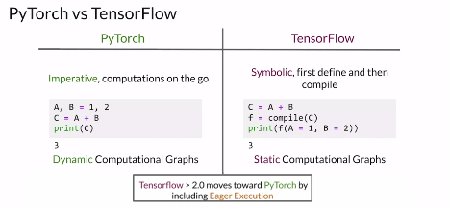
   * Transition from tensorFlow is much easier
   * Model using pytorch
   * 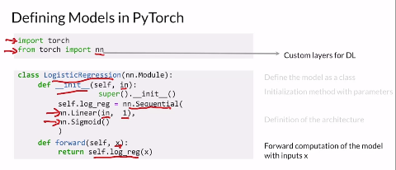
   * Train model
   * 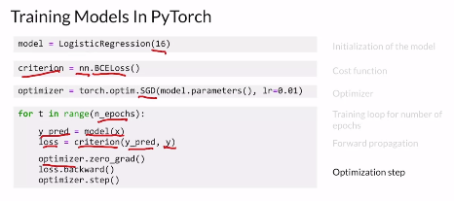
   * 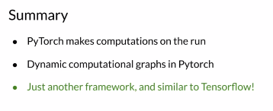

Week 2 :

1. Video 1 : Welcome
   * Examine componenets we used
   * Improve GAN in image generation
   * Relu sigmoid batch-normalization
   * Conv/pool layer
   * Deep Convolution GAN
   * DCGAN
2. Video 2 : Activations – Basic propreties
   * Activations functions
   * Takes any real number as input and output a number in certain range
   * Nonlinear function
   * Reason why they are nonlinear?
   * Gradient
   * Entire NN architecture
   * Node: take information from the previous layer
   * Compute z: weights with the output from the previous layer
   * Z => weighted the previous layers => linear layer
   * With bias term
   * Compute a: output of activation function
   * A = g(z)
   * Activation must be differentiable and nonlinear
   * Differentiable: you need it on the backpropagation to update parameters
   * Nonlinear to compute complex features
   * If not a complex neural network will be equivalent to a linear regression
   * 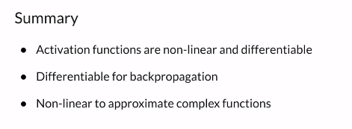
3. Video 3: Common activation functions
   * Important for DL
   * Most popular ReLu, Leaky ReLu, Sigmoid, Tanh
   * Rectified linear unit => not diffentiable at 0
   * Negative => derivative = 0 => don’t know how to update stop learning DYING RELU PROBLEM
   * Leaky ReLu solve this problem
   * We add slope <1 when z<0
   * Slope is a hyper parameter = 0.1
   * Sigmoid between 0 and 1
   * 1 / 1+exp(-z)
   * Used for probability
   * We don’t often use it on hidden layers but in last layers
   * Derivative approach zeros on tales => problem of vanishing gradient and saturation problem
   * Values will always be close to 0 or to 1 when we go to far
   * Tanh values between -1 and 1
   * We keep the sign of the input => could be important
   * Same issue of vanishing gradient and saturation as sigmoid
   * 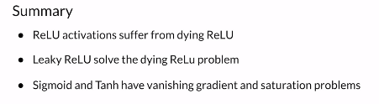
4. Video 4: Batch Normalization – Explained
   * GAN are fragile when they learn
   * We need to speed up and stabilizes the training
   * How normalization helps training
   * Different distribution of different features
   * 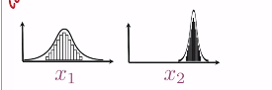
   * Comparison between them will not have a meaning
   * Will impact the way the model learns
   * 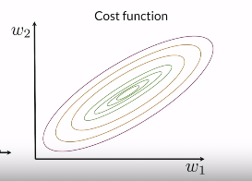
   * Difficult training and depending on the initialization
   * 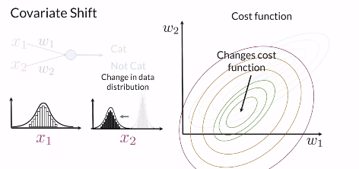
   * Covariate shift => change the data distribution
   * If they are normalized => will be similar mean = 0 std = 1
   * 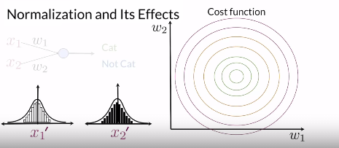
   * Faster training
   * Use the batch stats
   * As we train each batch we take the mean and the std, and we shift it to be around 0 and 1 respectively
   * Testing data uses training stats
   * We will have a reduction of covariate shift
   * Internal covariate shift
   * 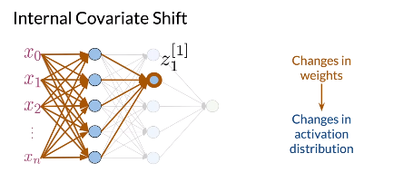
   * 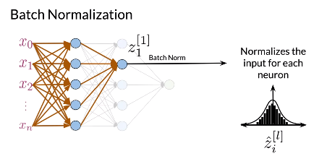
   * 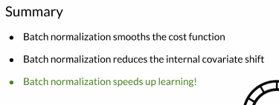
   * Covariate shift means that the distributions of some variables are dependent on another.
5. Video 5: Batch Normalization – Procedure
   * We can implement from scratch
   * Framework get it ready
   * Z for every example in the batch
   * Mean of batch and std of batch
   * 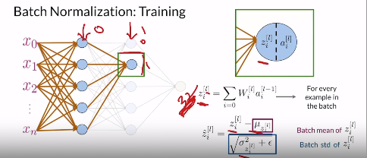
   * 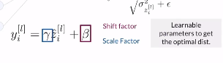
   * To get the optimal one
   * After normalizing we rescale
   * 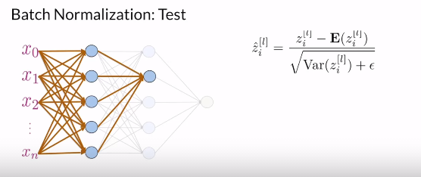
   * Use running mean and std after training
   * Just need a layer called batchNorm
   * 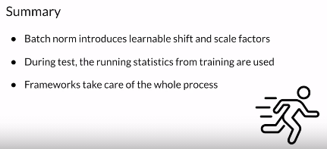
   * Make the training faster
   * We just need to know when to use it
   * You use the batch mean and standard deviation during training and the running statistics (that was computed over the entire training set) for testing. The running values are fixed after training.
6. Video 6: Review of convolutions
   * Central part of image processing
   * Detect key features using filters
   * One filter will tell you where is the eye, the other where is the nose .. etc
   * Each filter is matrix=> vlues are learned during training
   * 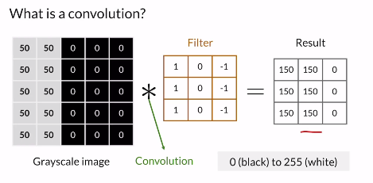
   * Vertical line detector
   * 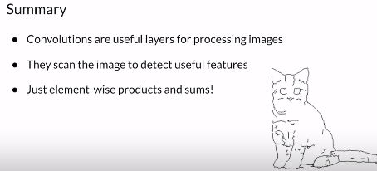
   * Convolutions reduce the size of an image while preserving key features and patterns.
   * Convolutions allow you to detect key features in different areas of an image using filters that are learnable during training.
7. Video 7: Padding and stride
   * Stride => how much pixel move
   * 1 pixel right 1 pixel down => stride = 1
   * Larger stride => less image covered => computation faster => reduce size
   * Determine how many section your filter will visit
   * Padding to save the size
   * On the center are visited multiple times well at the corner visited less times
   * Center => more attention => it’s problem => we could have important information on the edges
   * So we add padding
   * 0-padding usually
   * Each pixel will be visited the same times
   * 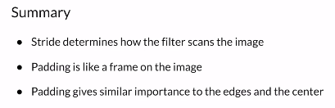
8. Video 8: Pooling and Up-sampling
   * Common layers in CNN
   * Pooling reduce the size of the input
   * Up-sampling increase the size of the input
   * Take the mean or the max or the min => pooling
   * Much less expensive to do computation
   * Don’t visit any pixel multiple times
   * Intermediate layer
   * Does not have any learnable parameters
   * Up-sampling => higher resolution => additional pixels
   * Nearest neighbors to fill
   * 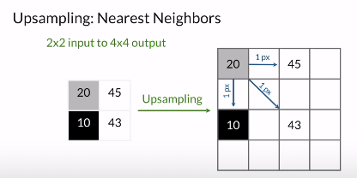
   * Linear interpolation
   * Bi-linear interpolation
   * 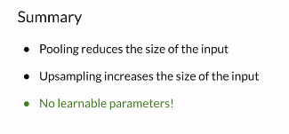
9. Video 9: Transposed convolutions
   * Learnable features
   * 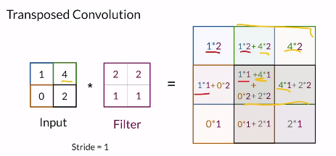
   * Center influence by all pixels and the other are not
   * Up-sampling + convolution to avoid check-board pattern
   * 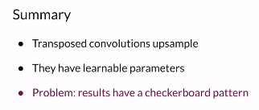
   * A transposed convolution uses a learnable filter to up-sample an image.
   * Up-sampling infers pixels using a predefined method, while transposed convolution learns a filter.

Week 3 :

1. Video 1 : Welcome
   * When the GAN is generating the same thing each time
   * Issue of discriminator
   * The generator will not know how to improve when the discriminator knows that this same type of image is fake
   * New loss function
2. Video 2: Mode Collapse
   * Mode collapse and vanishing gradient problems using BCE
   * 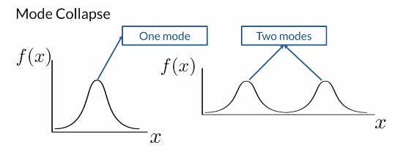
   * Multiple modes => pics
   * 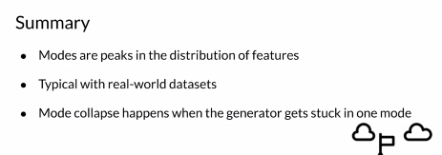
   * Mode collapse occurs when the generator gets stuck generating one mode. The discriminator will eventually learn to differentiate the generator's fakes when this happens and outskill it, ending the model's learning.
3. Video 3: Problem with BCE Loss
   * Binary cross entropy isn’t the best way
   * Vanishing gradient problem
   * Higher cost => the bad
   * Generator want to maximize the cost and the discriminator want to minimize the cost
   * Mini max game
   * 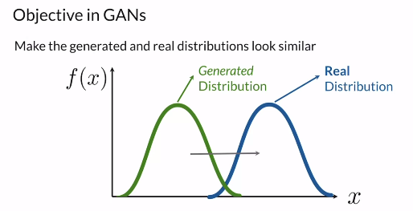
   * 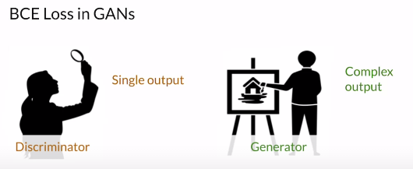
   * Discriminator job is easiest
   * 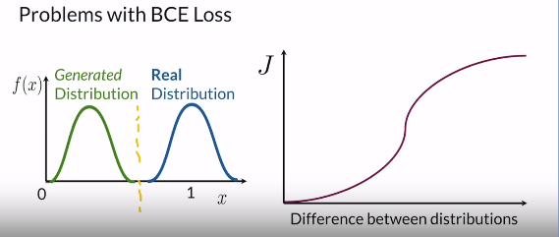
   * Start distinguishing between them
   * Gradient close to zero => generator have nothing to learn
   * The discriminator does not output useful gradients (feedback) for the generator when the real/fake distributions are far apart.
   * This is also called the vanishing gradient problem because the gradients approach 0 when the distributions are far apart.
   * 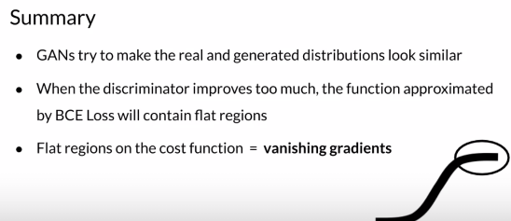
4. Video 4: Earth Mover’s distance
   * EMD
   * Solves the vanishing problem
   * Same variance different mean
   * Measures how different they are
   * 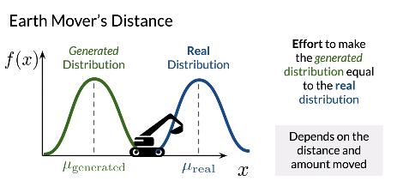
   * EMD no selling to 0/1 it will continue to grow regardless how apart the distributions are
   * 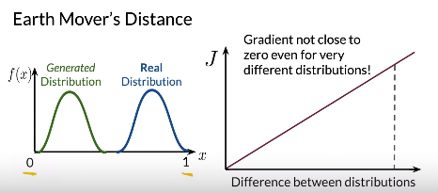
   * 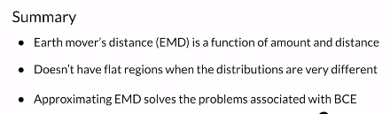
   * Earth mover’s distance is a measure of how different two distributions are by estimating the effort it takes to make the generated distribution equal to the real one.
5. Video 5: Wasserstein Loss
   * Approximate the EMD
   * BCE => how bad an average
   * Generator maximize that cost discriminator want to minimize
   * W loss approximate the EMD
   * 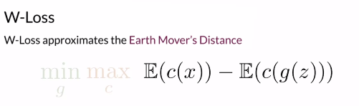
   * Fake and real images
   * Critic want to maximize distance
   * Generator minimize the disnatce
   * No log’s
   * 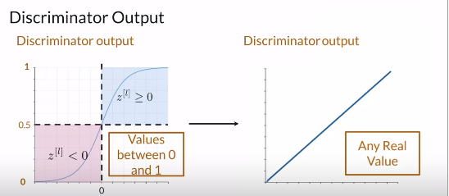
   * Critic = discriminator
   * Differences between BCE and W-loss
   * 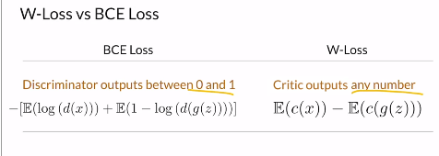
   * The W loss helps with mode collapse and vanishing gradient problems
   * 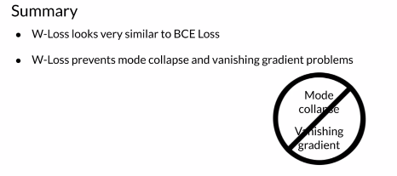
6. Video 6: Condition on W critic
   * Continually condition
   * 1-L continuous
   * Norm of gradient should be at most 1 for every point
   * 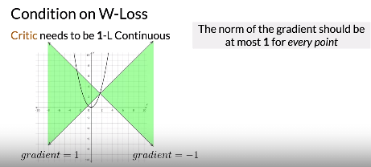
   * W-Loss valid => stable
   * 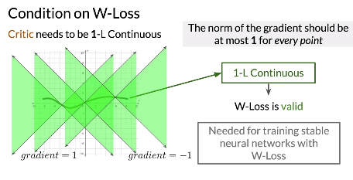
   * 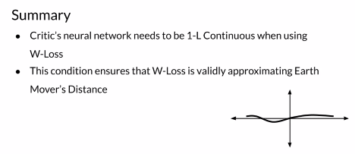
   * The slope can not be greater than 1 at any point on a function in order for it to be 1-Lipschitz Continuous.
   * A function is 1-Lipschitz Continuous when its slope is no greater than 1 at all points.
7. Video 7: 1-L continuity enforcement
   * Ensure that W-Loss is valid
   * Weight clipping and gradient penalty
   * 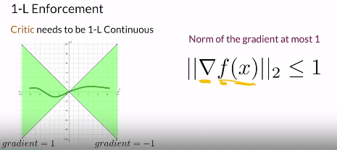
   * Weight clipping forces the weights of the critic to a fixed interval
   * Could limits the critic’s learning
   * 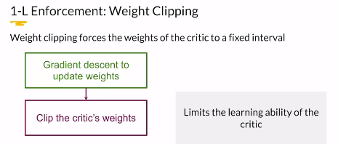
   * There is a lot of hyper parameter involved
   * Gradient penalty => add regularization term => penalize the critic when it’s higher than 1
   * 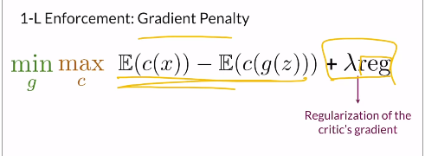
   * 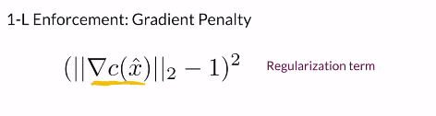
   * 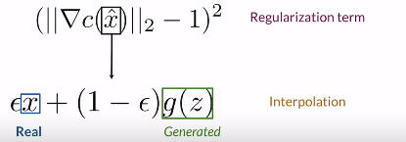
   * 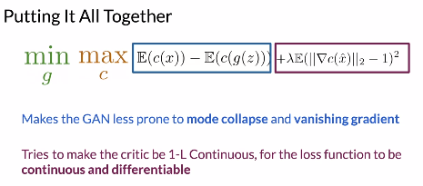
   * 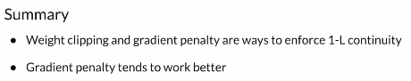
   * .Using the gradients on an intermediate image with respect to the critic is an approximation for enforcing the gradient norm to be 1 almost everywhere
   * Since checking the critic’s gradient at each possible point of the feature space is virtually impossible, you can approximate this by using interpolated images.
   * By using a gradient penalty, you are not strictly enforcing 1-L continuity, but encouraging it.

Week 4 :

1. Video 1 : Welcome
   * Control on what they generate
   * Un-conditionnel generation
   * Controllable generation
   * Adapt the input
   * 2 assignements
   * Condition + control
2. Video 2 : Conditional Generation intuition
   * Mimic the training dataset
   * Control the output of particular class
   * Unconditional generation
   * Outputs from random classes
   * Random noise until you get what you want
   * Comparaison between the two
   * 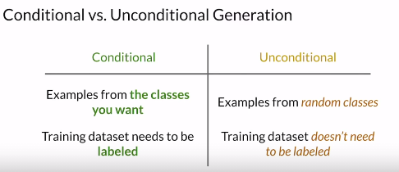
   * 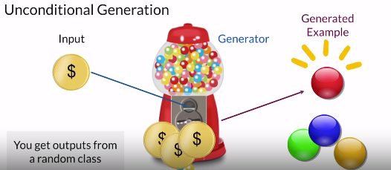
   * Conditional generation ask for an example from a specific class
   * 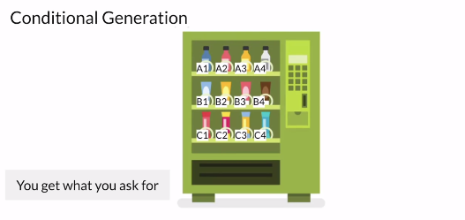
   * 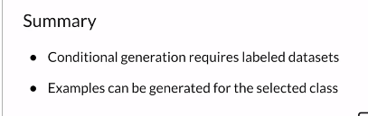
3. Video 3: Conditional generation inputs
   * Produce examples from the classes you want
   * Label dataset and pass this information to both generator and discriminator during training
   * Tell generator which class to produce
   * Noise vector to produce random examples
   * Class one-hot vector to know which class to generate
   * 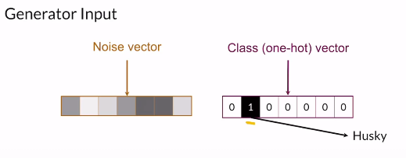
   * You want a husky example
   * Control + randomness on the generation
   * Ensure what generator produce => discriminator will know the class
   * Take examples + class
   * 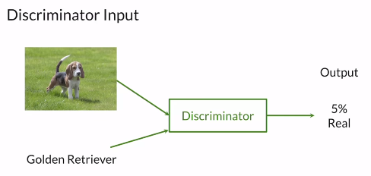
   * It’s fake
   * Training dataset with labels
   * Image + label => real
   * 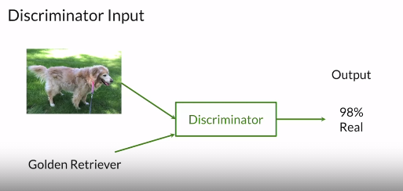
   * Real images will have the correct label images
   * Image RGB Channels + one hot channels to feed the class
   * 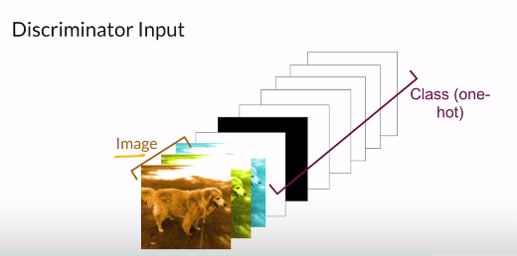
   * Matrix full of ones
   * 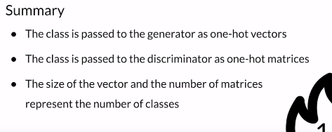
4. Video 4: Controllable Generation
   * Control outputs of GAN after it’s been trained
   * Control
   * Features you want on your output examples
   * Control age / gender
   * Tweak the input noise vector to get different features on the output
   * After train the model
   * Same face with different colors => tweak a part of z
   * Controllable GAN’s could include Conditional GAN’s
   * 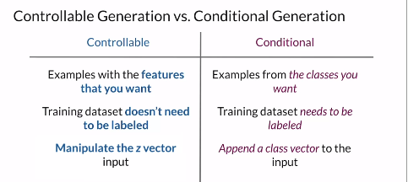
   * 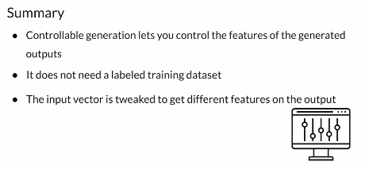
5. Video 5: Vector Algebra in Z-space
   * Manipulate noise vector
   * Interpolation in z space
   * How an image goes to another?
   * Interpolation using the z-space => noise vectors
   * Dimensions on z space
   * 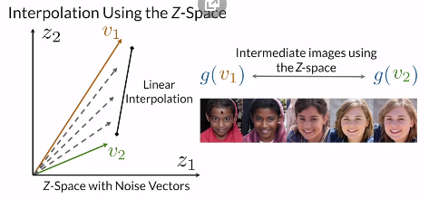
   * Linear interpolation => see what the generator get from the different noises
   * 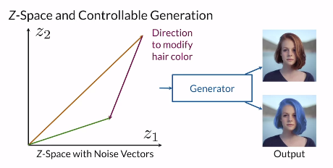
   * Direction on what to move to generate different hair color
   * Control output with direction
   * Add direction d
   * 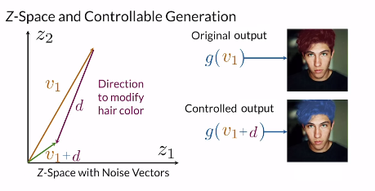
   * 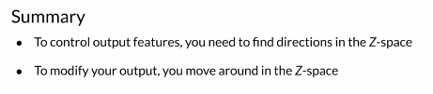
6. Video 6: Challenges with controllable generation
   * DECIDE FEATURES OF OUTPUT
   * Feature correlation
   * Control signal features => affected with others variables
   * 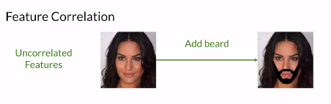
   * 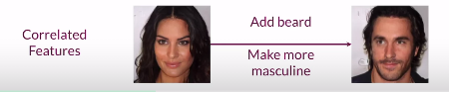
   * Modify many features
   * Entanglement on the Z-space
   * 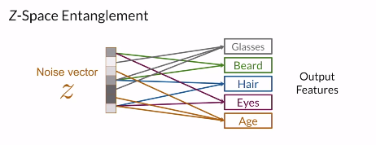
   * More features even if they are not correlated
   * It’s not quite disable
   * It’s not possible to control single output features
   * 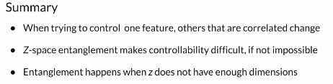
   * w hen features strongly correlate with each other and z values don’t correspond to clear mappings on their images.
   * When the Z-space is entangled, movement in the different directions has an effect on multiple features simultaneously in the output. This makes it difficult to control a single feature without modifying others.
7. Video 7: Classifier gradients
   * Moving on z-space
   * Find that direction using classifier gradients
   * Take noise vector
   * Go to generator
   * Pass it to classifier
   * Use info to modify z vector by moving on the direction of the classifier gradient
   * 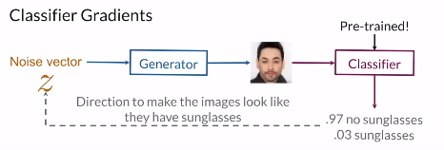
   * Modify just the noise vector until the features emerges
   * Need retrained classifier that accurately classify the feature that you want
   * 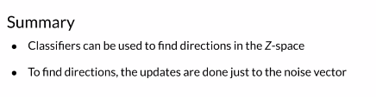
8. Video 8: Disentanglement
   * Disentangled z space
   * If this is a disentangled z space, then each of these positions would correspond to a singles feature
   * 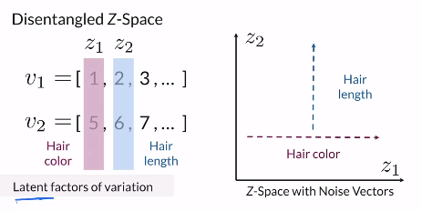
   * Size of noise larger as the size of features you want
   * The other values won’t impact the features values
   * Latent factors of variation
   * Only vary one feature / vector
   * Specific indices on the noise vector that change particular features
   * 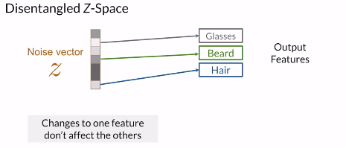
   * We can add beard to q women without changing the other features
   * Encourage Disentanglement: supervision
   * Add labels => one hot vector
   * Embedded to the noise vector
   * Difficult for continuous classes
   * 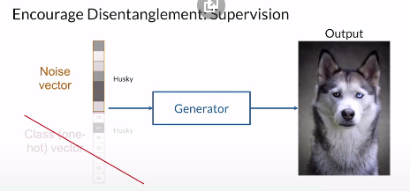
   * Encourage Disentanglement: Loss function
   * 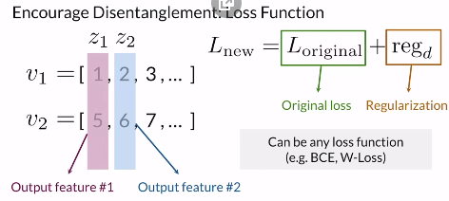
   * 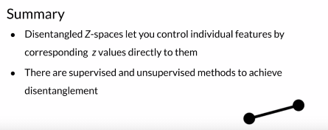
   * In a disentangled Z-space, specific indices on the noise vector correspond to a singular feature in the output.

Course 2: Build better Generative Adversarial Networks

Week 1 :

1. Video 1 : Welcome
   * Unsupervized Learning from a GAN
   * With GAN’s you want to be the composer who right notes not just the student who plays them
   * Higher level features
   * The patterns
   * Example for face generation => symmetric eyes, lips. etc. and compare with real images
   * Evaluate GAN
   * Disadvantages and bias
   * StyleGAN and advancements
2. Video 2: Evaluation
   * Understand criteria that you want your GAN to help
   * Fidelity and diversity
   * Similar to evaluate other model
   * Compare a saved model to a metric
   * Could be universal metric
   * Evaluate based on label => classifier
   * Test set => how right or wrong => metric for your model or other model
   * No concert way to tell how realistic is a generative image
   * We don’t know pixel you have to generated using a noise vector
   * Discriminator => doesn’t reach perfection => it over fit his own generator
   * A discriminator cannot be used for evaluation because it overfits to the generator it's trained with.
   * There is no universal discriminator that can look to 2 generators and know which one is better than the other
   * So how to evaluate GANs?
   * Define criteria and properties you want
   * 2 important properties
   * Fidelity => quality of images! How real are they?
   * Diversity => variety of images: different places and different positions => not just one realistic image
   * Consider both on the evaluation
   * Don’t want to memorize the training dataset
   * Fidelity => how nearest is from the real example
   * 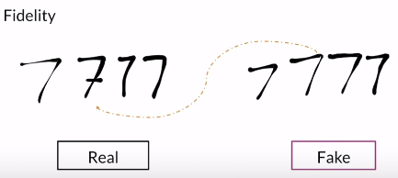
   * Diversity => cover the whole variety of the real distribution
   * 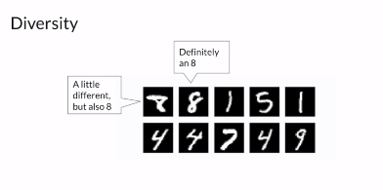
   * Criteria we car about to evaluate our generator
   * 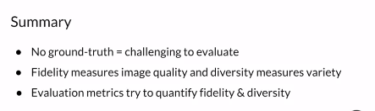
3. Video 3: Comparing images
   * Compare different images real vs fake
   * Pixel distance + Feature distance
   * What exactly should we compare
   * Absolute difference
   * 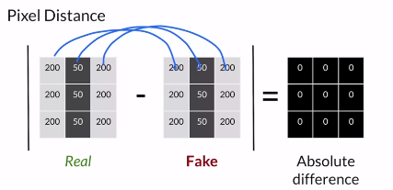
   * If we do the sum of the absolute difference matrix => equal to 0 => identical images
   * No distance from each other
   * If we shift => huge difference from the real image
   * 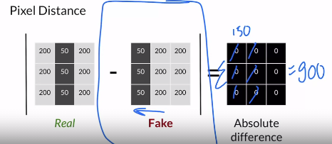
   * For real eyes => we will notice any difference
   * Alternative look at the features distance => high level
   * 2 eyes, nose position... etc. => will be less sensitive than the pixel shift
   * Explain image getting their features => use that extracted features to compare between them
   * 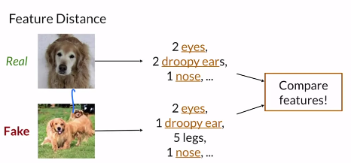
   * Very common with GANs
   * Less sensitive for small differences
   * 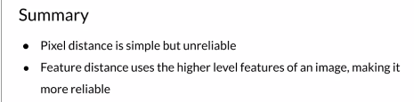
4. Video 4: Features Extraction
   * Extract features from images that you will use to calculate features distance
   * Using pre-trained classifiers to extract features
   * Image Net dataset
   * Features extractor => pre-trained classifier => classes similar to features you want to extract
   * Encoded features
   * 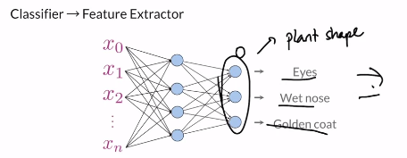
   * Abstract notions
   * New classifier every time => NO
   * Pre-trained classifiers => just change the last layers
   * Encode relevant features
   * 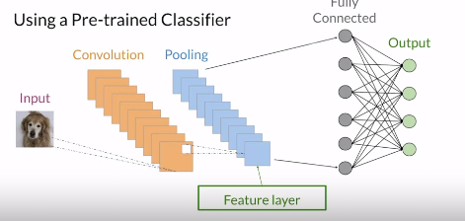
   * Drop the last layers
   * Use the last pooling layer => feature extracted
   * You can also use earlier layers
   * The last has the most information => could over fit the dataset
   * 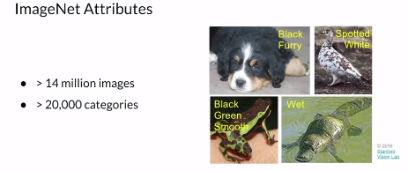
   * Image embedding => vector in certain space that represent the features
   * You can get a feature extractor by taking the weights from a layer of a pre-trained classifier. The weights of these pre-trained models have a lot of information about the features encoded within them.
   * 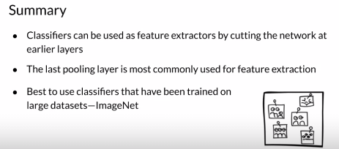
5. Video 5: Inception v3 and embedding
   * Neural network classifier => inception v3
   * 42 layers’ deep
   * Feature extractor
   * Cut off the last FC
   * Compress information about your image
   * 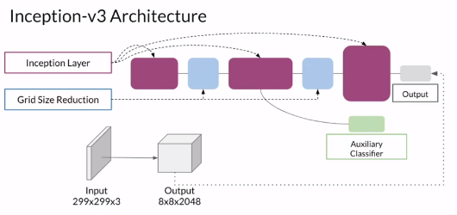
   * 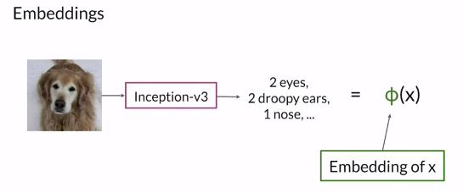
   * Phi = inception network
   * X the image
   * Embedding of on image => lower dimension
   * Very similar features
   * We compare embedding between real and fakes
   * 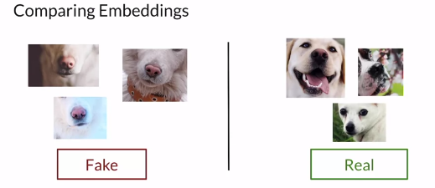
   * We can use Euclidian distance
   * Embedding => vectors
   * Extracted features are frequently called an embedding because they’re condensed into a lower-dimensional space.
   * 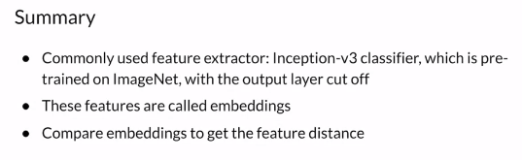
6. Video 6: Fréchet Inception Distance FID
   * The most popular metric for measuring the feature distance between real and generated images
   * Maurice fréchet
   * Dog walker
   * Dog on curve walker on other
   * Go on their own speed but neither of them can go backwards
   * Minimum length needed to walk the curves from beginning to end
   * Fréchet distance between normal distributions
   * 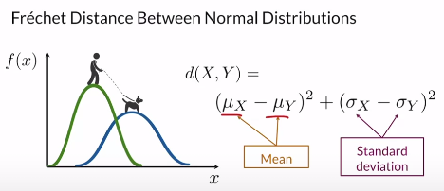
   * Penalize values further a lot from each other
   * Multivariate normal distribution
   * Model much more complex distribution
   * Picks in different areas
   * Easy way to visualize multivariate normal distributions is to visualize every dimension on a univariate distribution
   * How much each one affect the others
   * 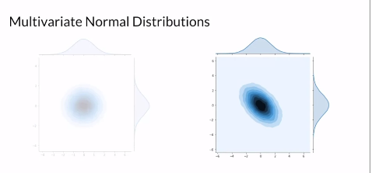
   * Affect each other differently => same normal distribution
   * Covariance matrix => variance between two dimensions
   * 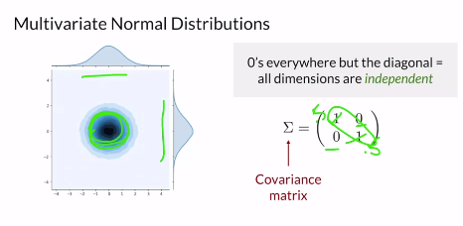
   * 0 => no variance
   * 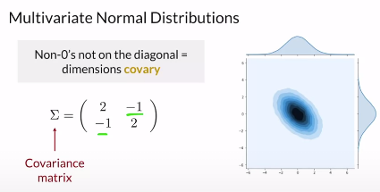
   * Negative => negative correlation
   * 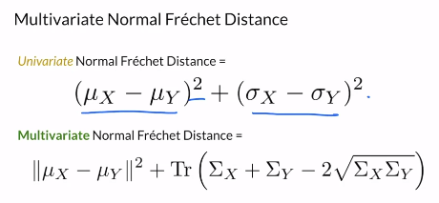
   * [Identités remarquables => motatabi9at chahira](https://www.mathematiquesfaciles.com/identites-remarquables_2_79742.htm)
   * TR => sum of diagonal
   * Variance with each self and not with the other dimensions
   * Sigma => std
   * Sigma ^2 =>variance
   * It’s a generalization $
   * 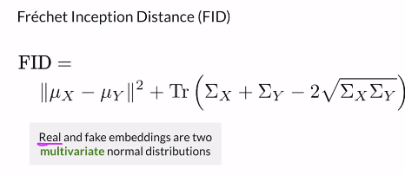
   * It’s easy to compute => not always accurate
   * 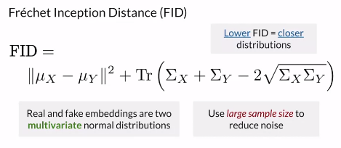
   * Lower is better => how far apart fakes are from reals
   * Reduce noise + selection bias
   * 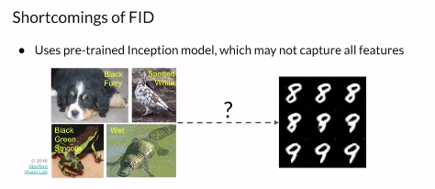
   * Need a large sample size => impact the score of FID
   * 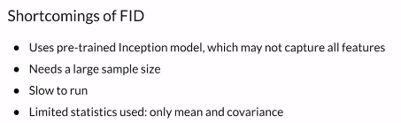
   * Easy to implement and use
   * 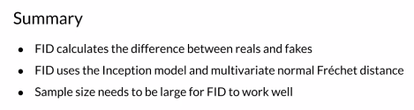
   * How does FID measure the difference between reals and fakes?
   * Should still baby-sitting your model
   * by considering the real and fake embeddings as two distributions and comparing the statistics of between those distributions.
   * FID looks at the mean and the covariance matrices of the real and fake multivariate normal distributions and calculates how far apart those statistics are from each other.
7. Video 7: Inception Score
   * Calculate distance between reals and fakes
   * Before FID
   * Another evaluation metric IS
   * We use classifier as it is and not as a feature extractor
   * No intermediate output
   * Output the class
   * 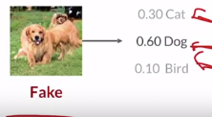
   * High fidelity
   * Classifier judgment
   * Diverse output => many different classes generated
   * See the distribution even all the classes
   * 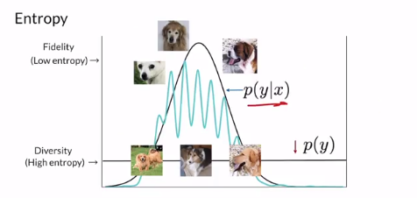
   * Fidelity => Low entropy
   * Diversity => High entropy
   * 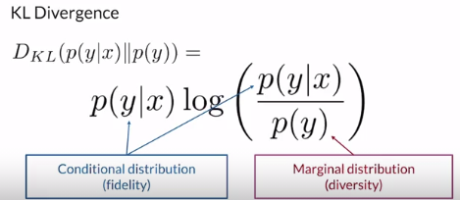
   * Score the model
   * KL divergence => uniform distribution on different classes
   * How difference the conditional distribution of fidelity is from marginal distribution of diversity
   * Relative entropy from the other
   * We want KL to be high => distributions are far apart
   * Inception score sum over all the images and average it
   * 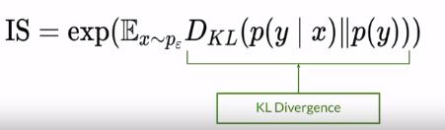
   * Sample from generator
   * Lower = 1 / higher = number of classes => practical
   * In theory from 0 to infinity
   * Lower => both distribution had low entropy => no pic high diversity
   * Or both had high entropy => no clear object found
   * Easy for diversity
   * 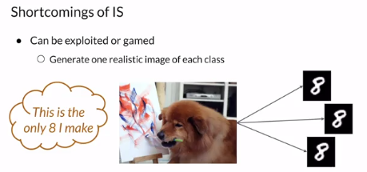
   * Only look at generated samples
   * Depend on classifier performance
   * 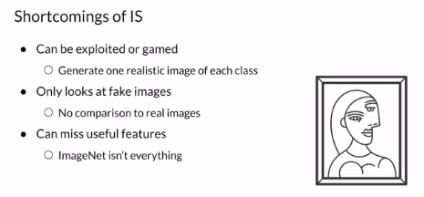
   * After FID, inception score is one of the most widely used metrics for GAN evaluation. A major shortcoming is that it only looks at the generated samples
   * FID uses intermediate features from the Inception-V3 network, while Inception Score uses the classifications directly.
   * FID compares reals and fakes, while Inception Score only looks at fakes.
   * FID and Inception Score both use the Inception-V3 network and look at samples, not the network parameters.
   * Most useful metrics after FID for GANs
   * 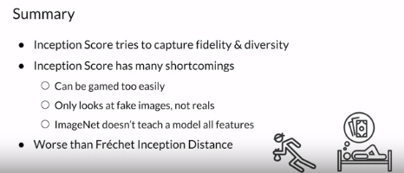
8. Video 8: Sampling and Truncation
   * Tricks for evaluating GANs
   * Sampling real vs fakes
   * The truncation trick
   * HYPE
   * Fidelity / Diversity
   * How to select which fakes images to sample?
   * Select based on training distribution
   * Noise vector from normal distribution
   * Centered on mean
   * Want it porch to this center
   * Image that look pretty good => fidelity less diverse
   * Center => more normal thinks
   * FID operate on samples of your model and not on the model parameters
   * Truncation trick => done after model being trained
   * Truncate the normal distribution from where you get samples
   * 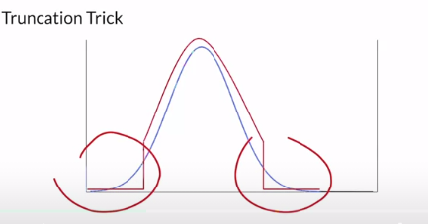
   * Not sample here => it’s a hyper parameter => how much of your tale you will keep
   * More or less from the curve
   * High fidelity => sample around 0 => truncate longer tale => but it will decrease diversity
   * Greater diversity => lower truncation => truncate smaller tale => lower fidelity
   * Train model on different distribution
   * It truncates the normal distribution that you sample your noise vector from based on a hyper parameter that determines how much of the tails to cut off or keep.

If you want higher fidelity, you want to sample around 0 and truncate a larger part of the tails. If you want greater diversity, then you want to sample more from the tails of the distribution and have a lower truncation value.

* + Normal distribution makes the truncated trick simple
  + HYPE and human evaluation
  + 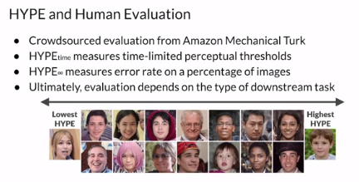
  + Huge part of process for developing a GAN
  + HYPE: Human eye perceptual evaluation
  + Flash => see when you realize that an image is real or fake
  + Better model => more time human need to distinguish and decide if it’s real or fake
  + Time thresholds
  + Depend on downstream task => ex pneumonia need doctor
  + 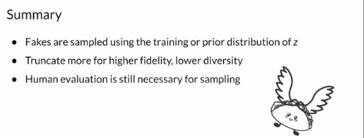

1. Video 9: Precision and recall
   * Evaluating concepts
   * Relate precision and recall to fidelity and diversity
   * More familiar machine learning concepts
   * 2 distribution
   * P-reals
   * P-generated
   * Best thing => p-generated = p-real
   * 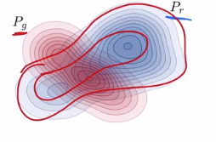
   * Intersection area
   * 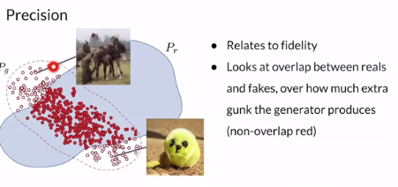
   * Overlap fakes / all fakes
   * Need huge intersection
   * Fidelity => precision
   * 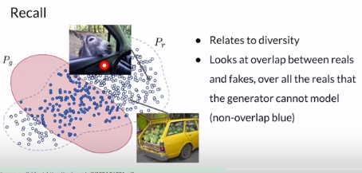
   * Overlap of reals/ all reals

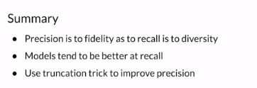

Week 2 :

1. Video 1 : Welcome
   * Positives of GANs
   * Down sides
   * Alternative GANs that are the problem
   * Bias
   * Loss function + evaluation metric
   * Blurry to high resolution
   * Handle the SOTA GAN
   * With great power come great responsibility
2. Video 2: Disadvantages of GANs
   * Previously How GANs => perfect result
   * High quality realistic images
   * Trained model => generate quickly => load weight + add some noise
   * 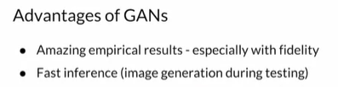
   * Disadvantages
   * Measure performance => lack of intrinsic
   * Approximate evaluation
   * Unstable training
   * 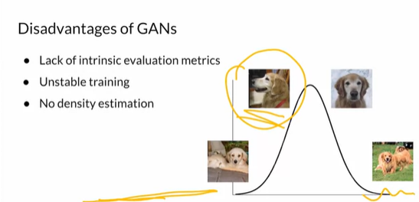
   * It’s more art than science
   * Need to babysit the model
   * No density estimation => likelihood
   * Useful for anomaly detection
   * Inverting is not straightforward => take image and figure noise => impossible
   * Opposite of the GAN
   * Bi-directional GAN
   * A significant advantage with GANs is that they can produce high quality realistic results. To the human eye, you could be fooled into believing these people actually exist. However, a downside is that during training, the model can be unstable and take considerable time to train.
   * 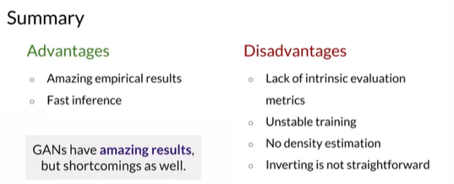
   * First AI model that generate realistic images
   * Output realism
3. Video 3: Alternatives to GANs
   * VAEs and other alternatives
   * Generative model => noise, class Y => feature X
   * Variational autoencoders
   * Work with encoder and decoder
   * 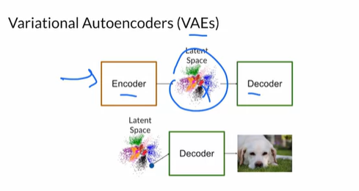
   * Maximise likelihood to real
   * Optimize
   * Blurry results
   * Don’t need the encoder after training
   * 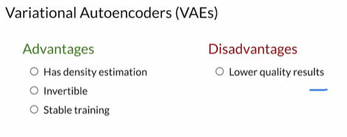
   * Need more engineering
   * VAEs work with two models, an encoder and a decoder, that take a real image, find a good way of representing that image in latent space, and then reconstruct a realistic image. A GAN takes noise as input and never directly sees the real image.
   * 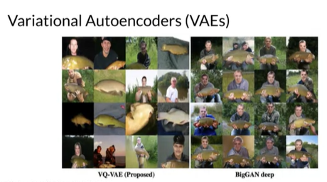
   * Autoregressive models
   * 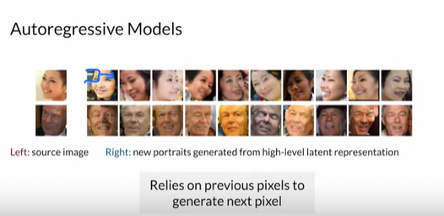
   * Look to previous pixel to determine the next pixels
   * Conditioning of the previous pixel what’s the future pixel
   * It’s supervize technique => can’t generate from nose
   * Flow model => invertible mapping
   * 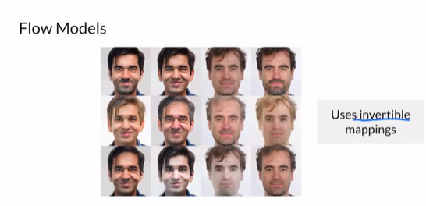
   * Start with simple and get more complex distributions
   * A generative model can be any machine learning model that tries to model P(X|Y).
   * Could get hybrid models => concept from more than one model
   * 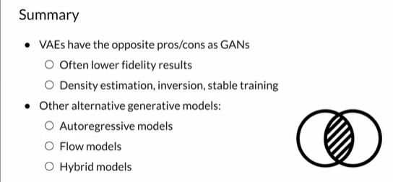
   * Realistic images are the goal => GANs are the better
4. Video 4: Intro to machine bias
   * Issue to machine learning
   * Bias in GAN
   * Eliminate bias
   * Impacts of biased
   * Risk assessment => likelihood of committing a crime in the future
   * Rely on machine learning
   * COMPAS Algorithm
   * Significantly bias
   * 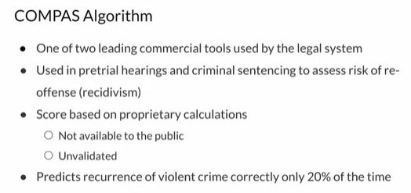
   * Questioning => evaluation of risk score => maybe biased due to the type of questions
   * Black and white defendants
   * 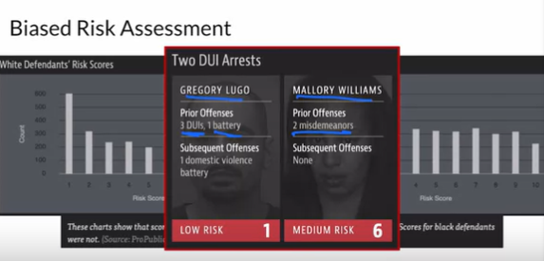
   * Black and white person => it’s biased
   * Model predicted in a biased way
   * 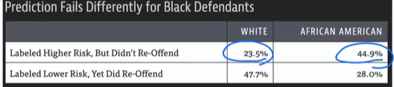
   * Reduce bias
   * 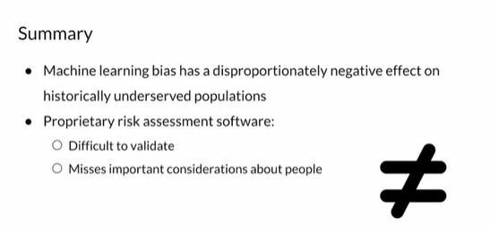

1. Video 5: Defining Fairness
   * Decide if model is fair
   * Evaluate if the model is fair or not
   * Complexity of defining fairness
   * 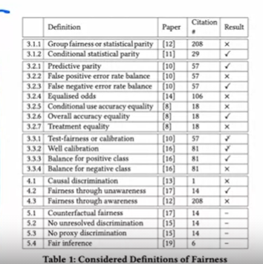
   * Equalized odds
   * Model => same prediction for each class
   * 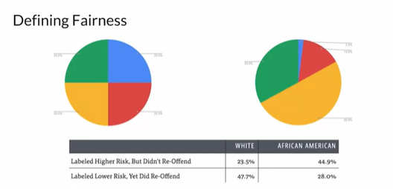
   * Different definition
   * No single definition of fairness
   * Demographic parity: the overall distribution of the predictions made by a predictor is the same for different values of a protected class.
   * Equality of odds: all else being equal, the probability that you predict correctly or incorrectly is the same for different values of a protected class.
   * Equality of opportunity: all else being equal, the probability that you predict correctly is the same for different values of a protected class.
   * Fairness is a complex ideal to define and these are simply a few common definitions that different research papers have relied on.
   * 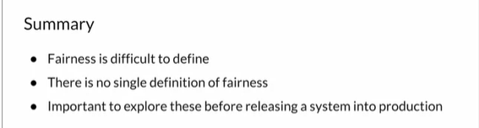
2. Video 6: Ways Bias is introduced
   * Many avenues
   * Ways bias can enter a model
   * During training
   * Training dataset => no variation
   * Bias in collection methods
   * Need Diverse dataset
   * Data labelling => diversity of the labelers
   * Evaluation Bias
   * Images can be biased to reflect correctness to a dominant culture
   * 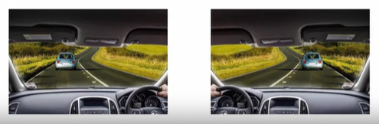
   * 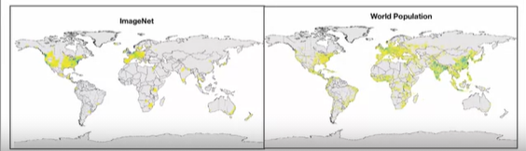
   * Image net => USA
   * Need other countries
   * 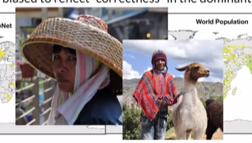
   * Model can make you think is a great at a certain task, when it actually unable to perform that task
   * Bias could be introduced from the model architecture
   * Can be influenced by the coders who designed the architecture or optimize the code
   * What looks good or bad
   * How various problem are chosen
   * 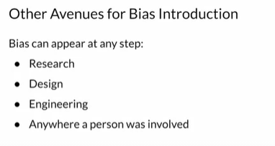
   * Bias GAN
   * PULSE => from pixelated image to up sampled image
   * 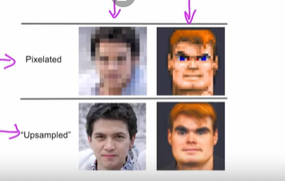
   * 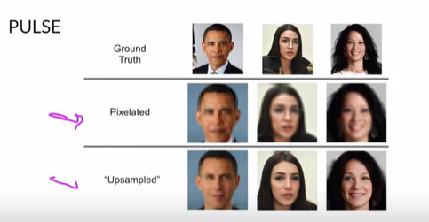
   * Un-recognizable faces
   * Bias => work with white people only
   * Where the bias is introduced
   * 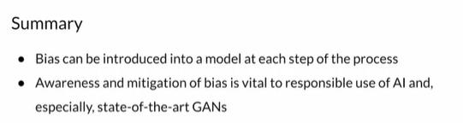

Week 3 :

1. Video 1 : Welcome
   * Improuvment of GAN
   * SOTA
   * Style GAN
   * Fidelity and diversity
   * Stable training
   * Control of genarting
   * Added noise
2. Video 3 : GAN improvements
   * How gan can improve
   * Which method
   * GANs over time
   * 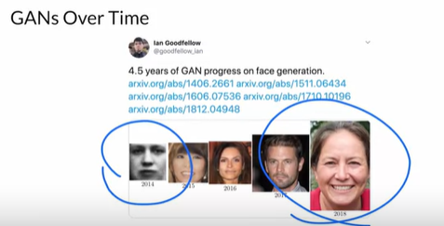
   * Training stability => train longer will not help
   * It’s stuck on a local minimum
   * No diversity
   * 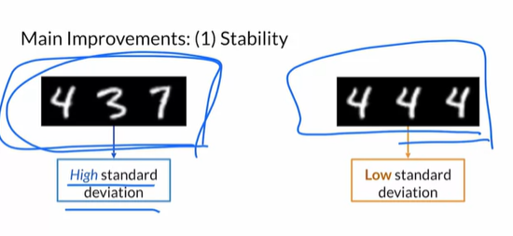
   * Mode collapse
   * STD show where we are approaching the mode collapse
   * One sample at time
   * Statistics in mini batch
   * 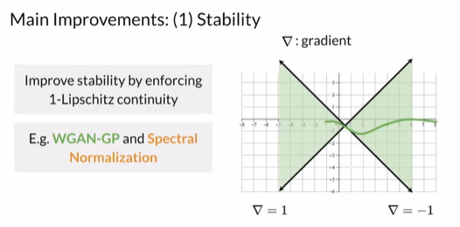
   * Function Be on the triangles
   * Spectral normalization
   * Like batch norm
   * Continuity
   * Moving average
   * 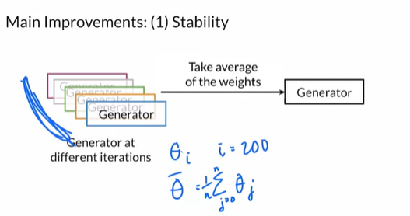
   * Done during trainer
   * 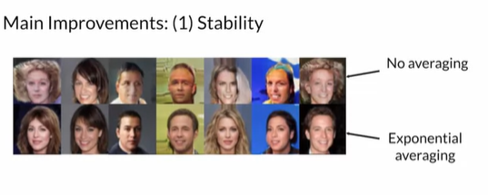
   * Smoother results
   * Progressive growing
   * 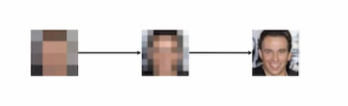
   * High quality images
   * Train for longer and improve
   * Progressive growing gradually trains GAN at increasing resolutions
   * Capacity DCGAN

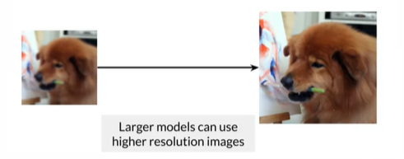

* + Diversity
  + Stability / Capacity / Diversity to improve
  + 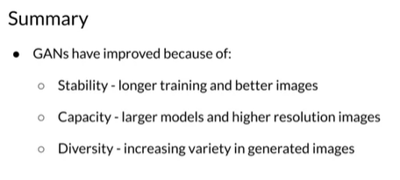

1. Video 3: Style-GAN overview
   * New architecture
   * SOTA GAN
   * Generate realistic hiûman faces
   * Goals style + components
   * Goals
   * 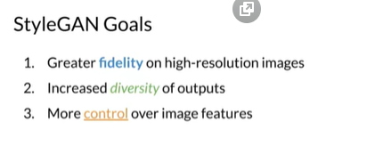
   * Smaller model capacity => problem
   * ProGAN
   * No fooling anymore
   * 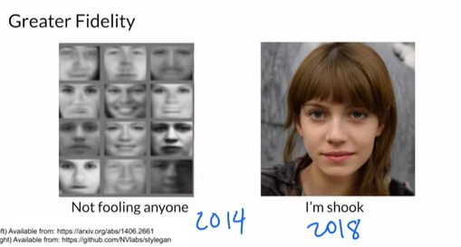
   * 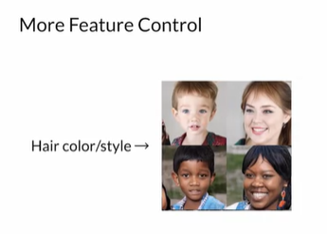
   * Control => get accessory
   * Style in GAN => any variation in the image
   * 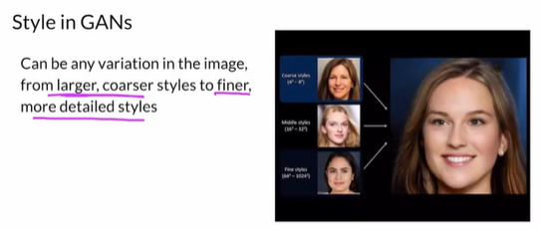
   * The style based generator
   * Traditional => noise => image
   * 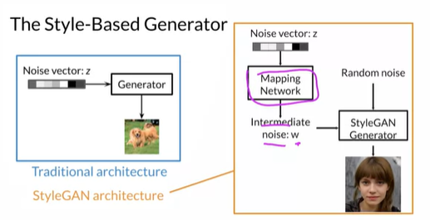
   * Mapping network
   * Add also a random Gaussian noise
   * Style extracted from w
   * AdaIN
   * Progressive growing
   * Process of training
   * GAN with progressive
   * Help on train high resolution image
   * 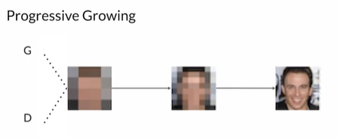
   * Go slow if you want to grow
   * 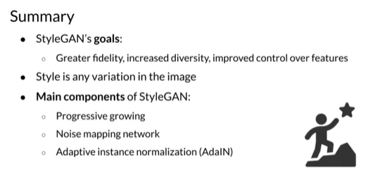
2. Video 4: Progressive Growing
   * Component of style GAN
   * Try make it easier for generator to generate high resolution images by gradually training it from lower resolution images to high resolution images
   * Blurry image => high resolution over time
   * Evaluate real of fake
   * High resolution over time for real and fakes to not make it too obvious
   * Convolutional layer => growing period
   * 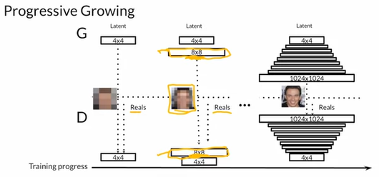
   * It’s more gradual than this
   * Up-sample the images
   * 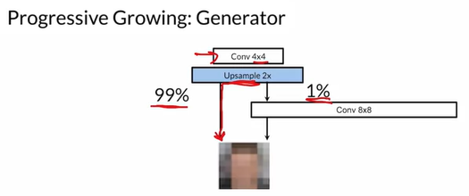
   * Learned parameters
   * 99% from up-sample / 1% from learned parameters
   * Decrease 99% and increase 1%
   * Just rely on learned parameters
   * 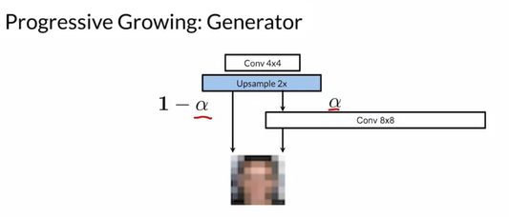
   * Alpha grows over time
   * Similar for discriminator on the other direction
   * 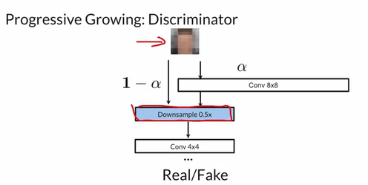
   * Reverse with the same alpha
   * Just one output => proba 0/1
   * Style => series of those
   * 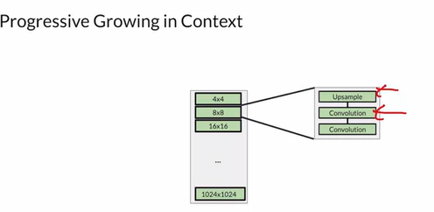
   * 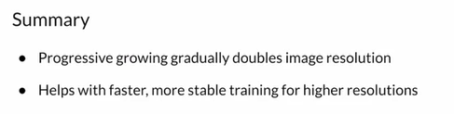
   * StyleGAN uses progressive growing to handle large image resolutions by gradually increasing the image resolution being generated by the generator.
   * More stable training
3. Video 5: Noise mapping network
   * Style GAN unique component
   * Takes noise and maps it into an intermediate voice vector w
   * Use very simple neural network with activations
   * Motivation: get more disentangles representation
   * 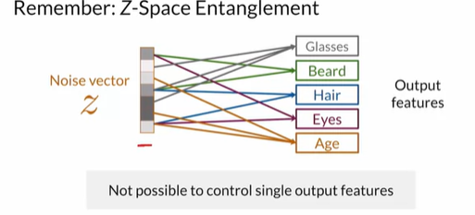
   * 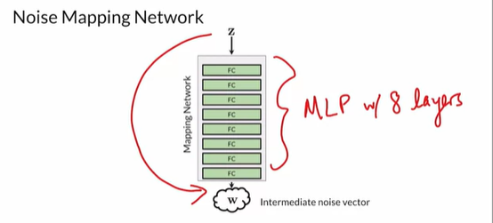
   * Real data has a proba density
   * Noise vector could not match the output features
   * 1 to 1 mapping
   * 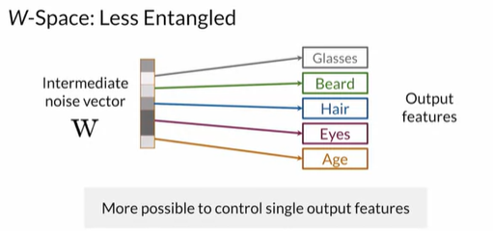
   * Learn variations
   * Help to control match feature
   * 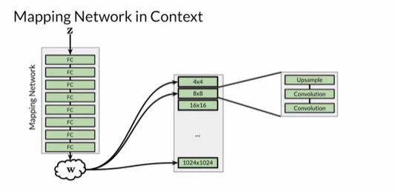
   * Having an intermediate mapping for the noise vector (z) allows the intermediate vector (w) to be in a more disentangled space. This makes it easier to learn 1:1 mappings.
   * 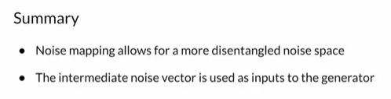
4. Video 6: Adaptive Instance Normalization AdaIN
   * How intermediate noise vector is integrated into the network
   * Up-sampling layer to double image size
   * AdaIN comes after each conv layer
   * 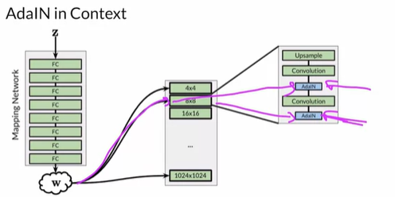

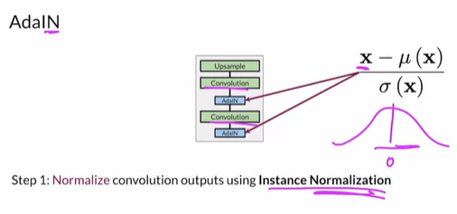

* + Instance norm look to only one example and only one channel of this example
  + Search only mean and std for this instance
  + Mean 0
  + STD 1
  + 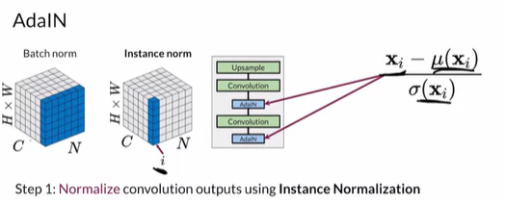
  + Apply adaptive styles
  + W go to FC => get parameters => statistics
  + Produce scale and bias
  + 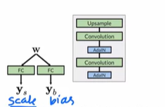
  + 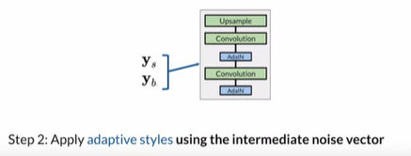
  + 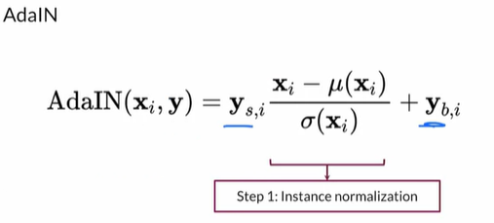
  + Re-shift and Re-scale
  + Adaptive styles
  + Every block control style
  + 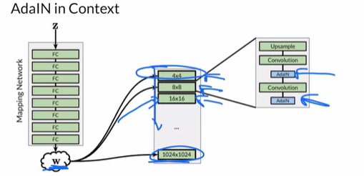
  + AdaIN blocks transfer learned style info from the intermediate noise vector (w) onto the generated image. They also renormalize the statistics so each block overrides the one that came before it.
  + 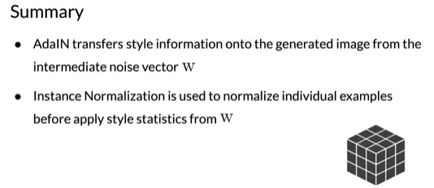

1. Video 7: Style and stochastic variation
   * Style mixing => increase diversity
   * Stochastic noise => additional variation: details
   * 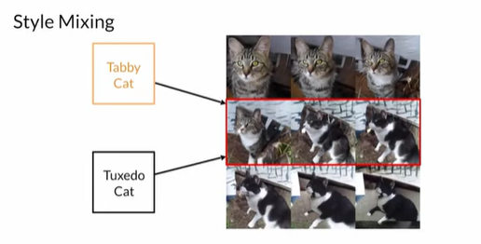
   * Don’t have to be the same noise w
   * Multiple w’s
   * Sample z’s
   * And inject them to samples of the network
   * 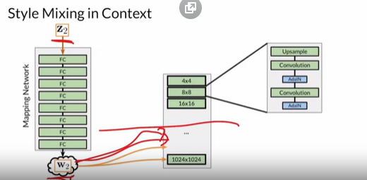
   * Each noise controls a part

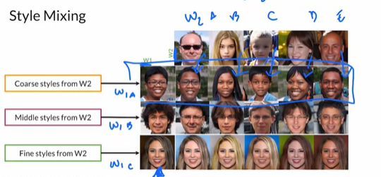

* + Mix of intermediate noises
  + Small variation that don’t need to mix images => stochastic variation
  + 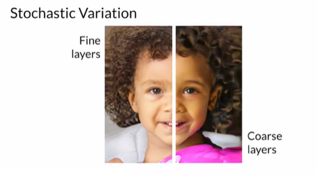
  + Add noise to the model
  + Fine layers
  + 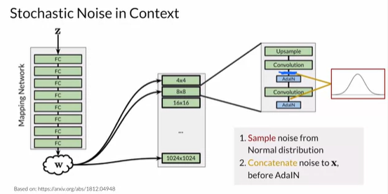
  + Randomness into the image
  + Control by factors lambda
  + Small details
  + Extra noise is injected at several different levels of StyleGAN, and affects the generated image in a different way depending on whether the noise was injected earlier or later.
  + 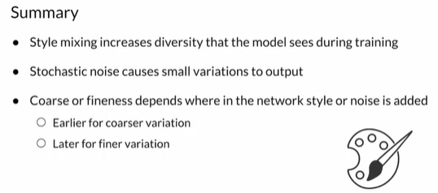

1. Video 8: Putting it all together
   * Style components together
   * Progressive growing => grow from smaller output to larger output => basic block from generator
   * Mapping network => NN => with activations
   * Injected on multiples parts
   * AdaIN
   * Control styles
   * Scale ans shift statistics
   * Style mixing
   * Stochastic noise
   * 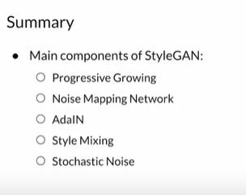

Course 3: Apply Generative Adversarial Networks

Week 1:

1. Video 1 : Welcome
   * Final course
   * Build complexe contrôlable GAN
   * Go to more sophisticated GANs
   * Data Augmantation
   * Artificial Data synthesis
   * Image to image translation
   * Low to high resolution images
   * Frame work image to image translation
   * Extend image to video
   * GAN generator DTA
2. Video 2: Week 1
   * GAN to help classifier or detector
   * Data Augmentation
   * Not enough data => Generate more
   * Con of GAN for privacy => sample is nearly identical to a real sample
   * Anonymity
   * Classification Task
3. Video 3: Overview of GAN Applications
   * SOTA GAN
   * 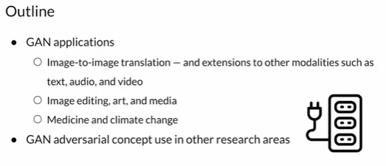
   * Translate from one style to another
   * Image to image
   * 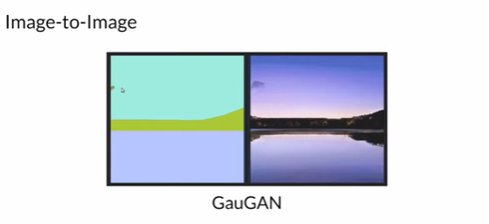
   * Different color => different classes
   * 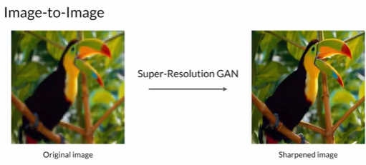
   * Higher resolution => more realistic than up-resolution
   * 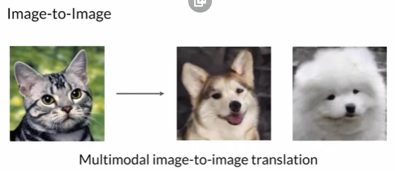
   * Model don’t know the classes => non supervized

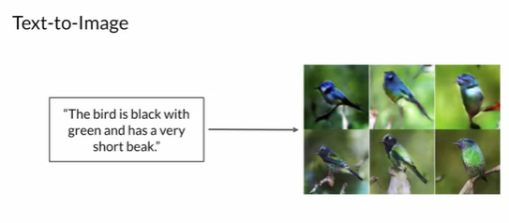

* + Text to image
  + Variance image that match a sentence
  + 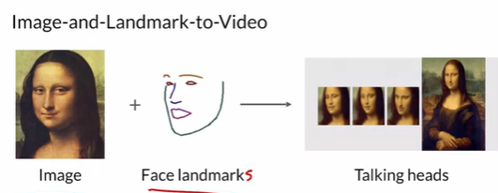
  + Image and landmark to video
  + Talking heads
  + Image filters
  + 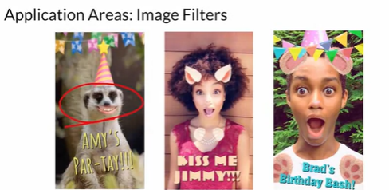
  + Image Editing
  + 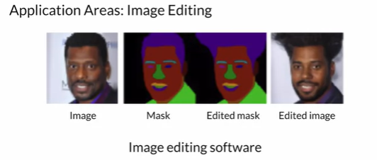
  + Image editing software
  + Stylized images => art work
  + Democratized art
  + Data augmentation
  + Increasing dataset size and diversity using generated samples
  + Medicine => simulating tissues SOTA GAN
  + 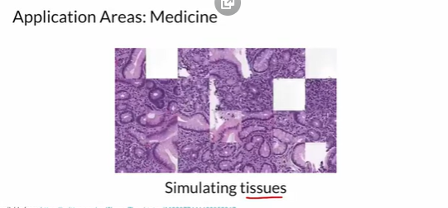
  + Climate change
  + 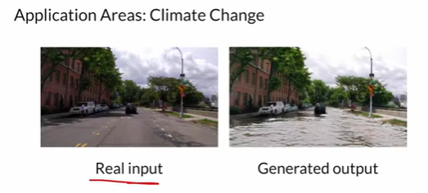
  + Help visualization future
  + Media => deep fake
  + Steel identity
  + Adversarial areas
  + Realism of the output
  + 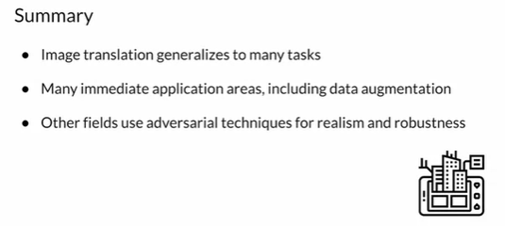

1. Video 4: Data augmentation methods and uses
   * GAN play part
   * Supplement data when real data is too expensive or too rare => not enough of it
   * Additional data
   * GANs are well suited for this
   * How to augment data
   * Input image => rotate translate blurry flip zoom filter GAN
   * GAN => generate images for different class
   * Orientation background .. etc
   * Use all of the methods + GAN
   * 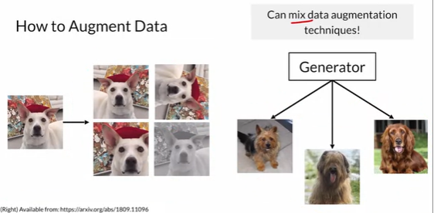
   * Rand Augment
   * Use cases
   * 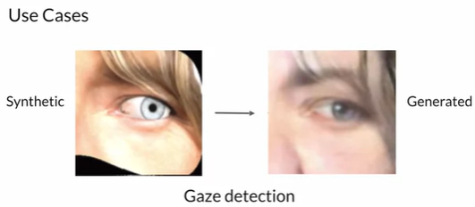
   * Gaze detection
   * Synthetic example
   * Social science application
   * Hard to collect and very costly
   * Speech emotion recognition
   * 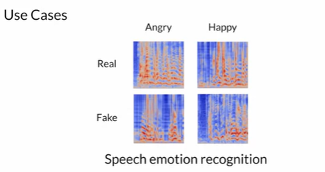
   * Alexa google home ..etc
   * Spectrum of frequencies
   * Very hard to obtain : ex brain cells
   * 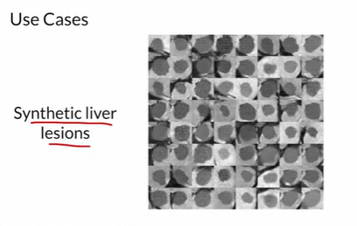
   * 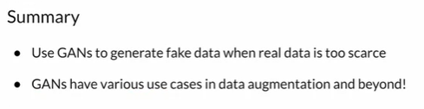
2. Video 5: Data Augmentation: Pros and Cons
   * Pros
   * Better than hand crafted synthetic examples
   * Mimic real examples
   * Generate more labeled examples
   * Improve downstream model generalization
   * 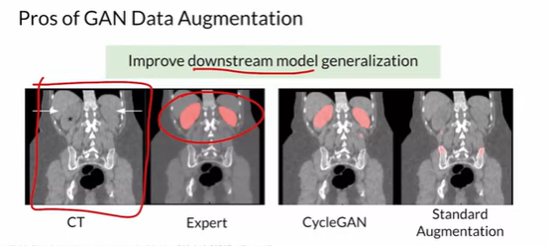
   * Mimic what the expert is doing
   * Cons
   * Diversity is limited to the data available
   * No useful when over fit to real data => will not be helpful => just like training another epoch
   * 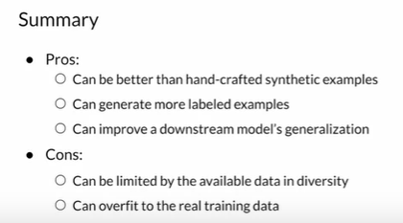
3. Video 6: GANs for privacy
   * Medical privacy example
   * Protect real patient data
   * Reverse engineering => problem
   * Encourage data sharing
   * 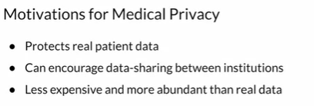
   * GAN tissue patches look real to pathologist
   * GAN MRIs look realistic
   * Classification and segmentation
   * Don’t use reals => privacy
   * 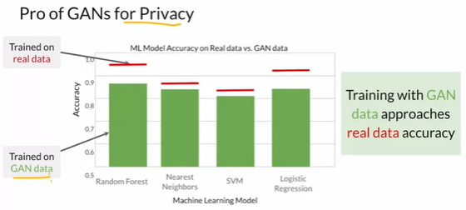
   * How well model does on just real data and GAN data
   * Con: Identical to real => no privacy
   * Close => removed / not used
   * Different type of samples
   * 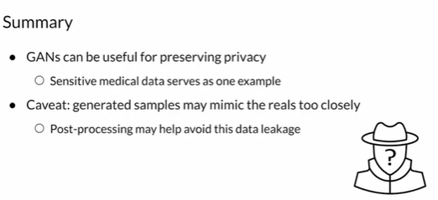
4. Video 7: GAN for anonymity
   * 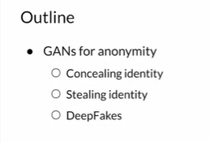
   * De-identified => anonymity
   * 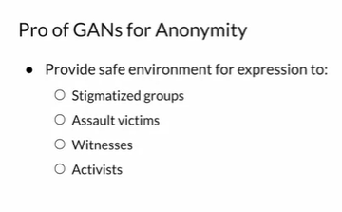
   * Safe environment for expression
   * 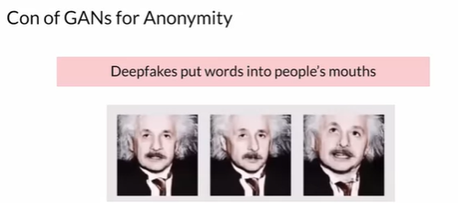
   * Deep-fake put words into people mouths
   * 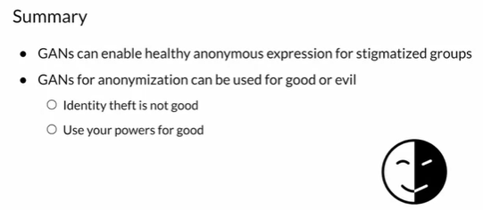

Week 2:

1. Video 1 : Welcome
   * Apply GAN
   * Image translation
   * Transfer style
   * Satellite image to map routes
   * Sketches to realistic images
   * Pix2Pix
2. Video 2 : Image to Image translation
   * 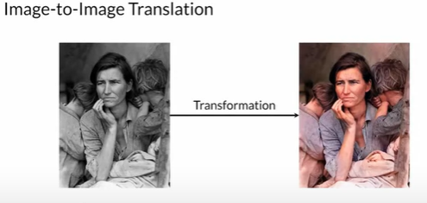
   * Diffèrent style : conditional transformations
   * Segmentation map to realistic vues
   * 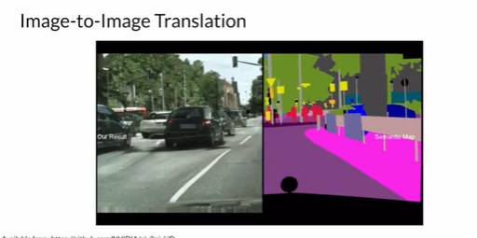
   * Frames of video => more than one image
   * Super resolution
   * Paire image ro image translation
   * 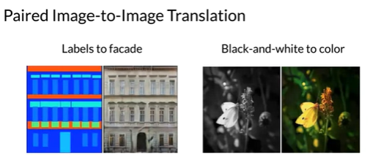
   * Input => target image with different style
   * A lot of different buildings
   * A ground truth not THE ground truth
   * Paired translation means that you have input-output pairs that map exactly onto each other (1-to-1).
   * 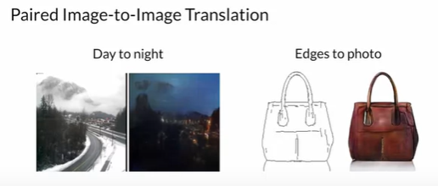
   * 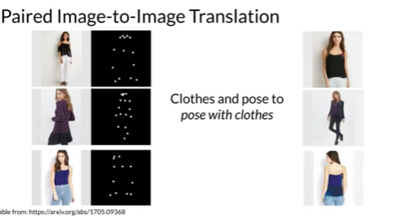
   * Another translation that go beyond images
   * 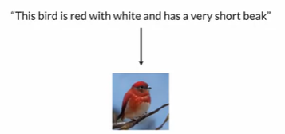
   * Text to image
   * Neural talking head
   * 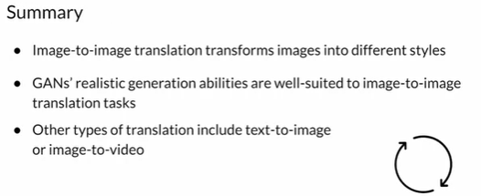
3. Video 3: Pix2Pix Overview
   * Conditional GAN that does paired image to image translation
   * Pixel to pixel
   * Condition on the input image
   * 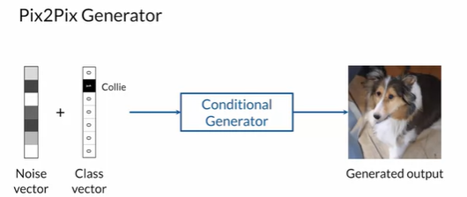
   * 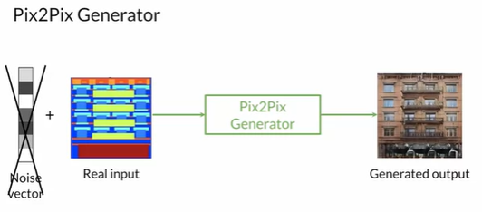
   * Real input
   * Different color => different classes
   * Use Drop out
   * Randomness to the output
   * Segmentation => realistic
   * 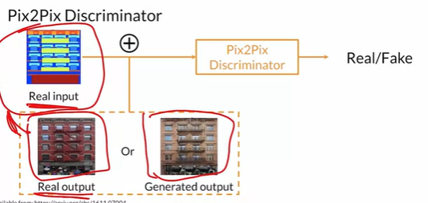
   * Random noise doesn’t change with the model learns
   * Upgrades
   * U-Net => use for segmentation => generator
   * Patch GAN => discriminator => more feedback
   * 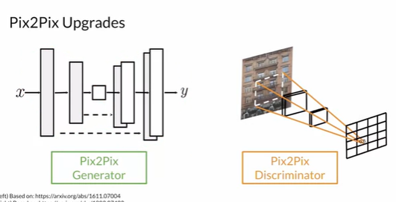
   * Goal still: Produce realistic outputs
   * 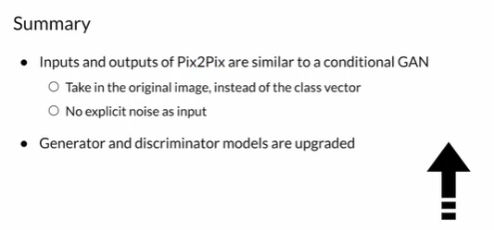
4. Video 4: Pix2Pix Patch GAN
   * Frist component
   * Discriminator output matrix of classifications instead of single output
   * 0/1
   * 0 fake 1 real
   * Does that for all pathches
   * 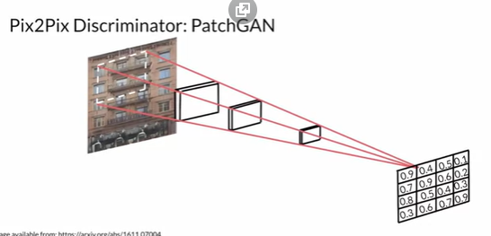
   * Feedback on each region and patch of the image
   * Discriminator want output of all 0 => fake label
   * Use BCE loss
   * All 1 => real
   * The PatchGAN discriminator outputs a matrix of classifications=> realness
   * 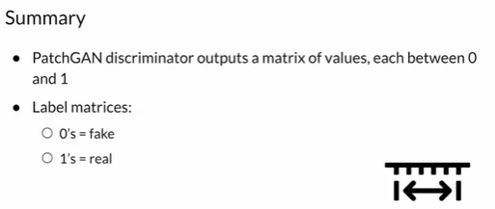
5. Video 5: Pix2Pix U-Net
   * Upgraded Generator => Based on U-Net
   * 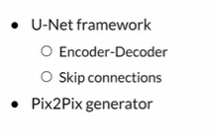
   * U-net => CV for segmentation
   * Labels on every pixel on the image => class that belong to
   * There is no correct answer
   * 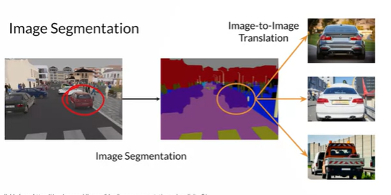
   * Image to image translation task
   * Map to output
   * Generation task
   * Go Back and ford
   * Tiny noise vector => input of u-net
   * Need convolutions to hand images on the input
   * Bottleneck => embed information => compress
   * Encode and decode
   * 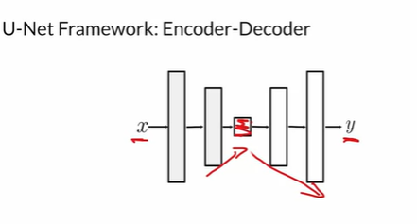
   * Easy to overfit => use skip connections
   * 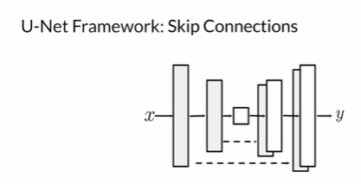
   * Extra connections on the decoder
   * Skip connections => concatenated
   * Flow for earlier to later
   * 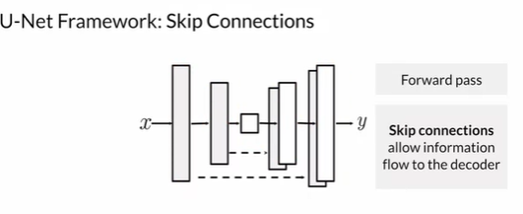
   * 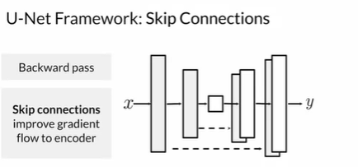
   * Gradient flow => vanishing gradient problem
   * Improve gradient flow
   * Stride of 2
   * 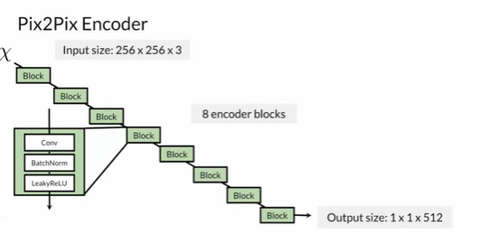
   * Encoder and decoder blocks => same number of blocks
   * 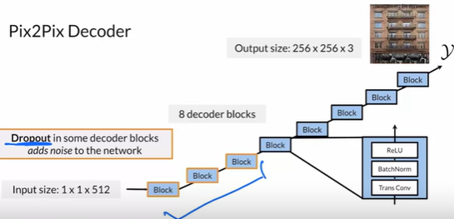
   * Transpose convolution
   * Drop out on the first 3 layers
   * Drop out in some decoder blocks adds noise to the network
   * Disable different neurons => allow different neurons to learn
   * Only on training
   * 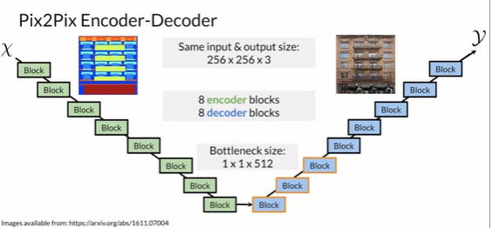
   * 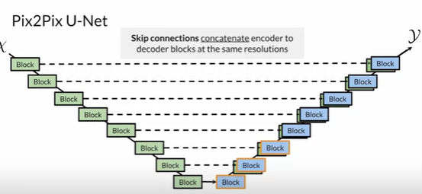
   * Integrate information from the encoder to the decoder
   * Skip connections concatenate encoder to decoder blocks at the same resolutions
   * 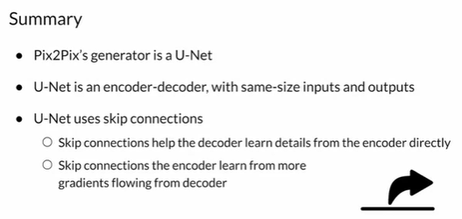
6. Video 6: Pixel Distance Loss Term
   * Regularization + loss term
   * Encourage pixel distance between generated and real outputs
   * Additional loss term for pix2pix generator
   * Adversarial loss term => main loss => BCE, W ..etc
   * Additional loss term => L1 regularization, gradient penalty ..etc
   * Lambda => weight loss < 1
   * 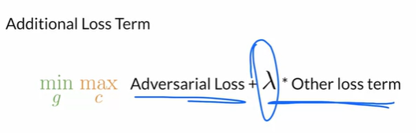
   * 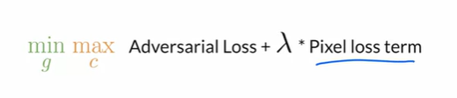
   * Match more closely
   * 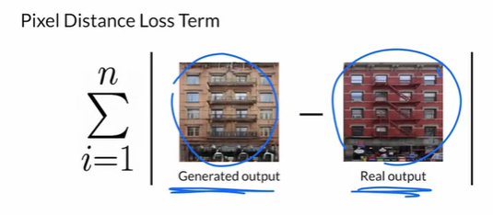
   * Pixel distance => real look like fake => small => 0
   * Close to realistic
   * Sees real image => paired image
   * 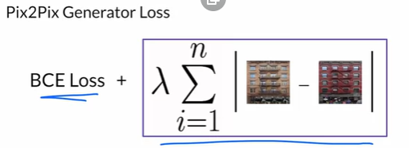
   * 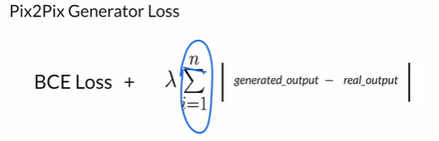
   * L1 distance
   * 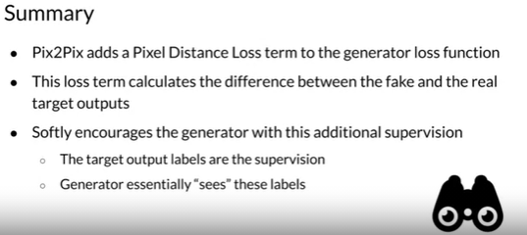
7. Video 7: Putting it all together
   * 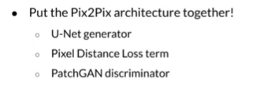
   * Segmentation mask
   * Realistic looking the map the mask
   * U-Net => generated output
   * Concatenated with real => go to the discriminator
   * Classification matrix
   * 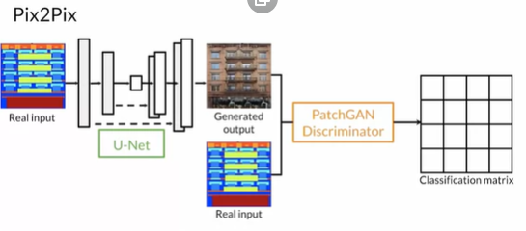
   * Discriminator loss => conmapre to fake label matrix
   * 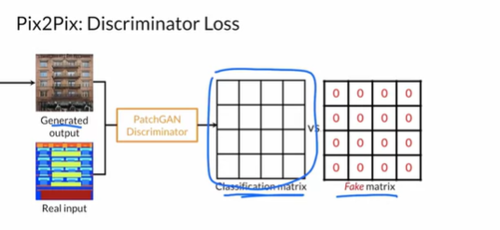
   * 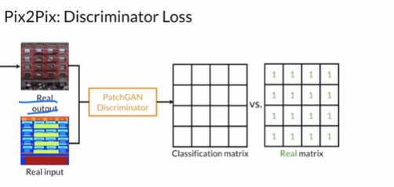
   * Concatenated on the channel dimension
   * Real and fake matrix
   * 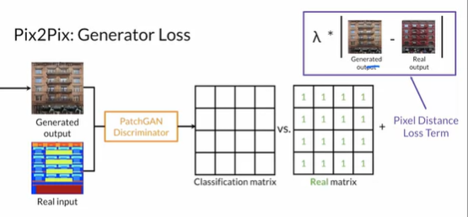
   * The generator loss
   * 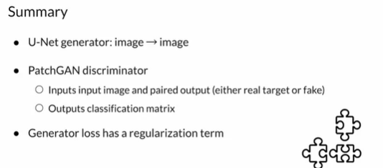
8. Video 8: Pix2Pix advancements
   * Many improvments
   * 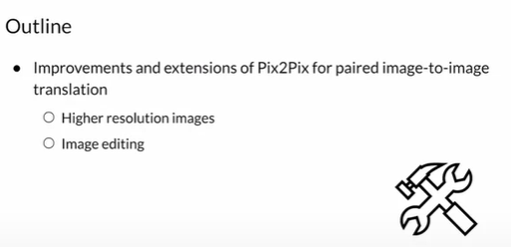
   * Another model => high resolution
   * Pix2PixHD
   * Adapt the generated mask as you like
   * Don’t change the mask => but a lot of possible
   * GauGAN
   * 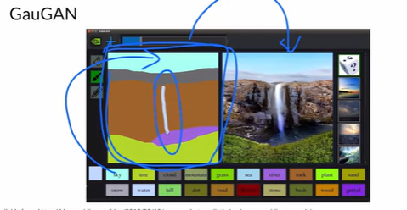
   * Uses style GAN
   * 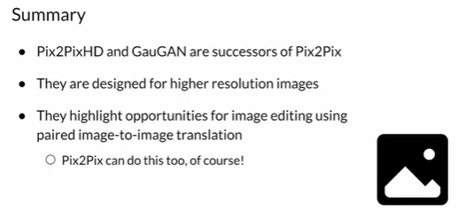

Week 3:

1. Video 1 : Welcome
   * Last week
   * Image translation
   * Unpaired
   * 2 GANs figure the mapping
   * Horse Zebra / Zebra Horse
   * Diffrent styles
   * 2 GANs form a cycle
   * Cycle GAN
2. Unpaired Image to image translation
   * Unpaired
   * 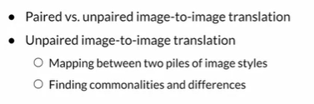
   * Pair => input output pairs
   * 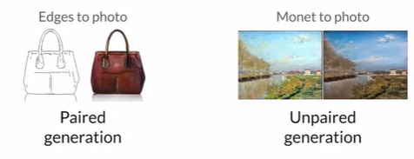
   * No paired training data
   * Paradigme => don’t have correspendance
   * 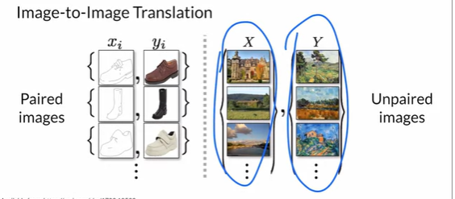
   * 2 piles
   * No one to one correspondance
   * Transform from one pile to another
   * 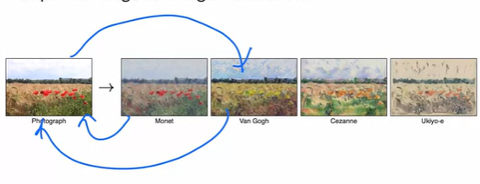
   * Content preserve => different stylistic
   * Keep what’s common and transform style
   * Zebra and horses
   * 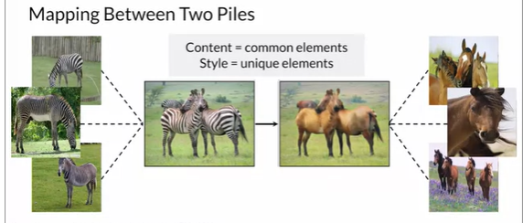
   * Style => different element => unique to each pile
   * There is no longer a clear target output.
   * WIth unpaired image-to-image translation, you can just have a pile of images in one style and another pile of another style.
   * 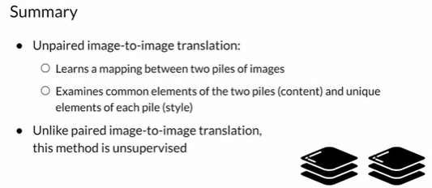
3. Video 3: Overview Cycle GAN
   * Unpaired image to image translation
   * Two GAns which compose Cycle GAN
   * Might sound impossible
   * He don’t know what to generate
   * Cycle consistency
   * Transform back => fake
   * 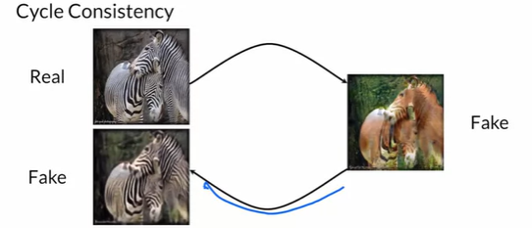
   * Should be the same
   * 2 different GANs
   * 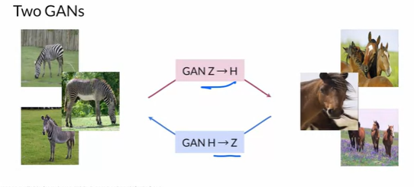
   * Only moving the style
   * 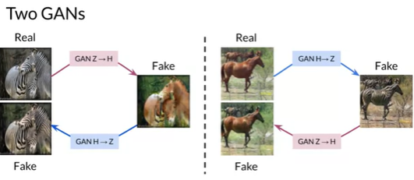
   * Architecture
   * Discriminators => patch GAN
   * Generators => U-Net
   * Down and up sampling
   * Add DC GAN
   * 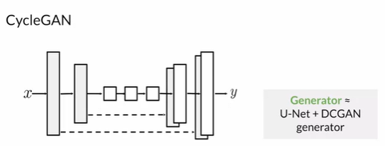
   * New architecture ¨
   * Improvements
   * Add skip connections
   * 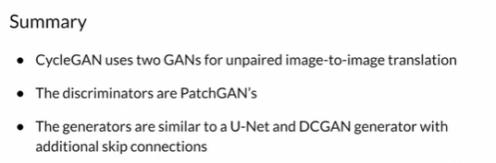
4. Video 4: Cycle GAN => 2 GAN’s
   * How 2 GANs interact with each other
   * 2 generators / discriminators
   * 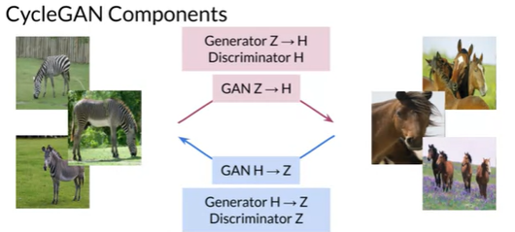
   * One direction
   * 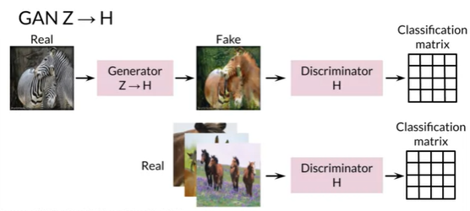
   * 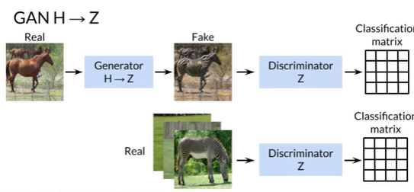
   * Opposite direction
   * No target output
   * 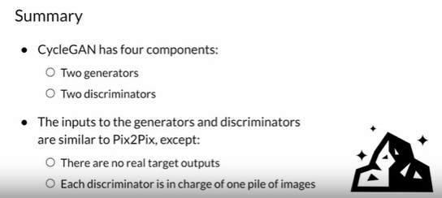
5. Video 5: Cycle GAN: cycle consistency
   * 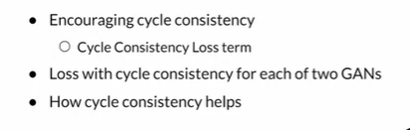
   * Extra part to the loss function
   * Zebra to horse direction
   * 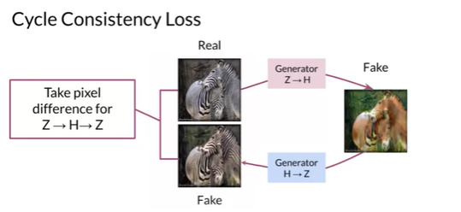
   * Cycle consistency want the generated one to look exactly like the real one
   * Pixel differences between images and add it to the loss
   * We do it on the two direction
   * 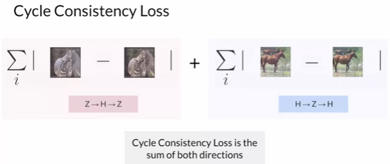
   * One optimizer
   * 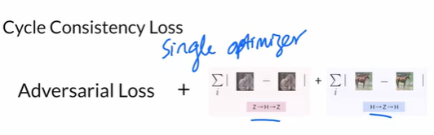
   * 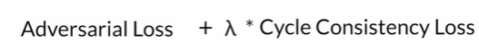
   * Used across dep learning
   * Ablation studies
   * 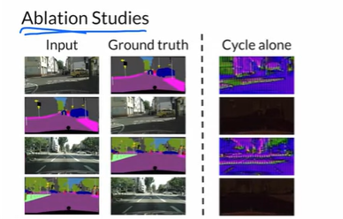
   * How far from the ground truth?
   * Just with cycle => no realism
   * Without adversarial GAN loss, outputs are not realistic
   * GANs alone
   * 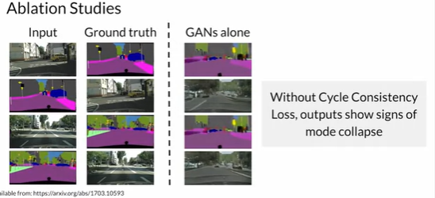
   * Mode collapse
   * 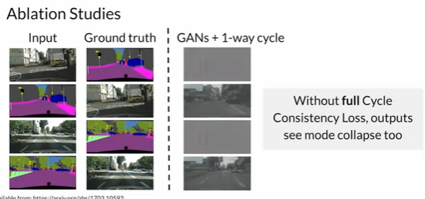
   * Full GAN
   * Use both
   * 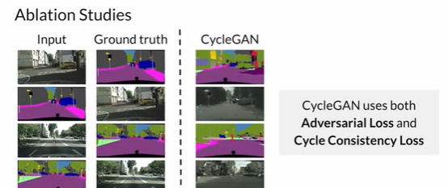
   * Diversity
   * 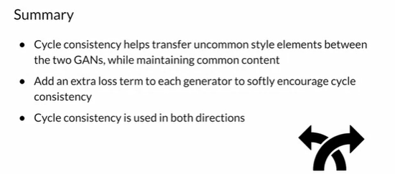
6. Video 6: Least square loss
   * Replace BCE and w Loss
   * 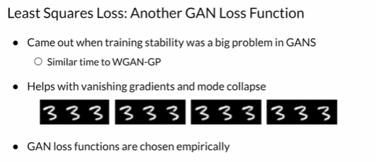
   * Least square concept from stat => minimizes the sum of squared residuals
   * It tries to find the best fit line that has the smallest sum of squared distances between the line and all the points
   * 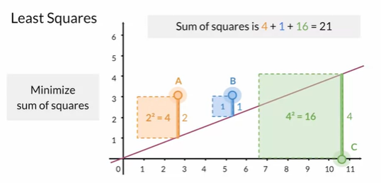
   * Best fit line
   * GAN land
   * Use label
   * 1 real / 0 fake
   * Across many different points
   * 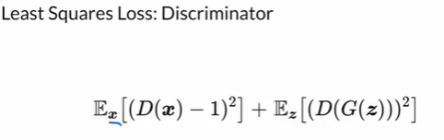
   * Want to see how far it from 1 => generator
   * 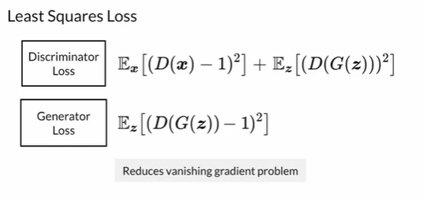
   * Better training stability => MSE mean square error
   * Least Squares Loss and BCE Loss both calculate the distance between an image and the ground truth.
   * 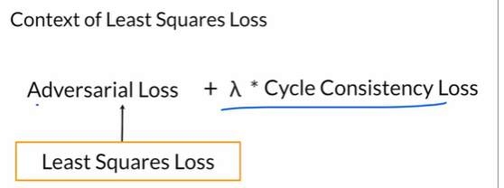
   * 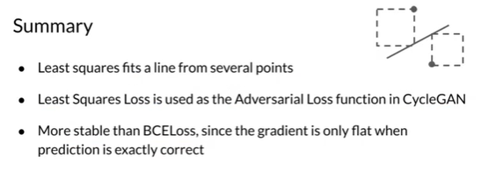
7. Video 7: Identity Loss
   * How it works and how it impacts outputs?
   * It’s an optional loss term => mainly to help with color preservation in the outputs
   * Ideal output
   * 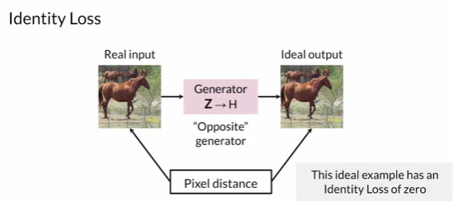
   * 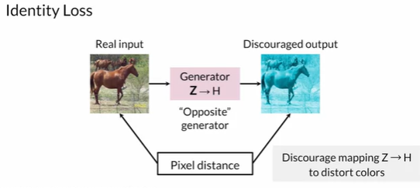
   * 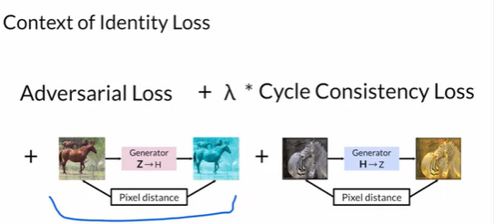
   * 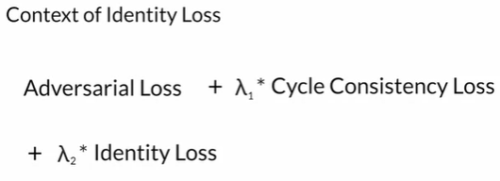
   * Identity loss helps preserve original photo color
   * 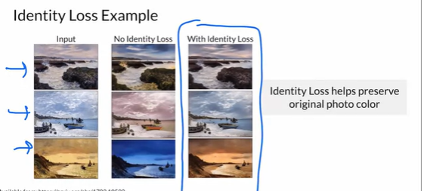
   * 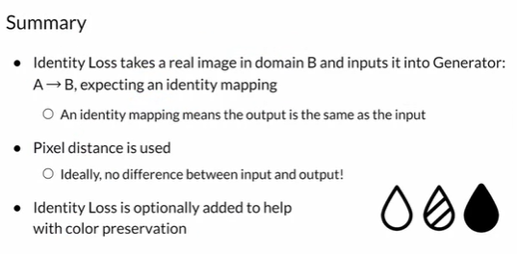
8. Video 8: Putting it all together
   * 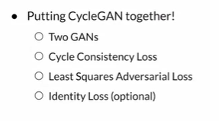
   * 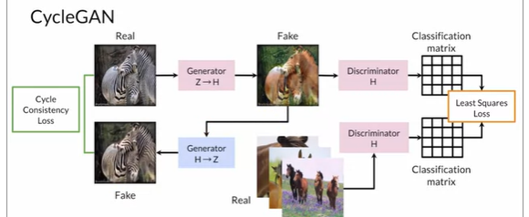
   * 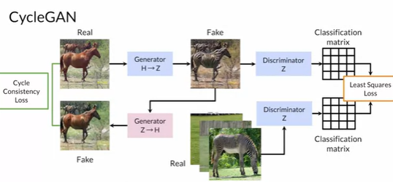
   * 2 directions
   * Identity loss
   * 
    